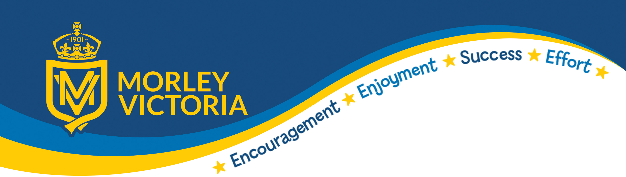

Name of Policy: Nursery Admissions Policy

Date to be reviewed: Spring 2026

Signed: J Hardaker

Purpose of this Policy
The purpose of this policy is to inform parents about fair allocation of school nursery places and to provide clear information on how we prioritise children’s needs when allocating places.
We have tried to mirror the school admissions policy as far as possible to ensure smooth transitions to school. Please note the allocation of a nursery place in school does not guarantee a Reception place. There is a separate admissions policy for school places.
Basic Eligibility criteria

Children will be admitted to Morley Victoria Nursery for free nursery education following their third birthday. Children below eligible age will not be admitted.

Once eligibility is established, we will then offer places to children taking into account the additional priorities below.

Priority 1

Children who are three years of age and who will be eligible to start school in the next academic year.

Priority 2
Children with siblings who will be at Morley Victoria at the start of the academic year – they must be living at the same address.

Siblings refers to brother or sister, half brother or sister, adopted brother or sister, stepbrother or sister, foster brother or sister. The definition does not include cousins or other family members sharing a house.

Priority 3

Children of parents who live nearest Morley Victoria Nursery.
If we have more applications than there are places, we will offer places first to
children living nearest to the school nursery (measured in a straight line from your home address to the school in accordance with the Leeds City Council School Admissions system) if two children match in distance then they will be taken in age order – oldest first.

In the unlikely event there are insufficient places for two or more children living in the same building (e.g. flats) or otherwise equidistant from the school, then any final place will be allocated by the drawing of lots.

Address
For admission purposes, the home address is where the child usually lives with their parent or carer. You must not give the address of a childminder or relative.

Special Needs and Circumstances

Morley Victoria is an inclusive school and we welcome children who have special needs and requirements. We would appreciate knowing if your child is/has:

- in public care or is fostered under an arrangement made by the local authority.

- a social worker for any reason.
- the subject of a Child Protection Plan.

- Special Educational Needs, or exceptional medical/mobility needs.

If your child has any additional needs, we would be grateful to see any documentation from professionals who have been involved so we can provide the best possible care. For advice you must contact the SEN Assessment and Provision Service on 3951035.

We will need to discuss this with you when a place becomes available as we are mindful of our capacity to fully cater for your child’s needs. Accessibility to our school site is particularly difficult.

Flexible provision.

All school nurseries are required to deliver flexible 30-hour free nursery education where there is demand.

At Morley Victoria we have assessed parental demand and considered our operational limitations. We have the following places on offer:

30 hours free childcare (should families meet the eligibility criteria)
15 hours (Option 1) – Monday, Tuesday and Wednesday morning
15 hours (Option 2) – Wednesday afternoon, Thursday and Friday

The children remaining in school over lunchtime must bring a packed lunch and will be charged £2.50 per lunchtime as this does not form part of the inclusive 15 or 30 hours, it is in addition.

The Nursery children will be welcome to access our ‘Before and After School Care’ provision, Basement Buddies. Families will be charged for using this service. This service is also available on school training days for the benefit of Morley Victoria families.

Admission of children following their third birthday

Children may be offered a place at any time during the term following their third birthday. The nursery will continually assess availability of places and make offers to the next family on the waiting list, in order of priority. Children will be invited to start in the Nursery on a mutually agreed date that is appropriate to both the family and the Nursery.

Admission of children still in Nappies

Children who still have continence issues at Nursery admissions age will not be refused entry to Morley Victoria Nursery. However, as we encourage independence, if this is an issue, we will be discussing this matter with our families as a matter of urgency.

Looking ahead - starting Reception age
The School Admissions Policy allows all children to start full time Reception education in the September following their fourth birthday. You must ensure your child receives an appropriate full-time education from the term following their fifth birthday. Almost all children start school in Leeds in the September following their fourth birthday.

In exceptional circumstances you may feel that it would benefit your child to defer their place into school and for them to remain in the Nursery for an additional twelve months. You will still be required to complete the School Admissions Forms when they become available but then state that you wish to defer the place. It is likely that you will have to attend a panel meeting to explain why you feel this would benefit your child. The decision will then be made by the Local Authority.

If you are considering deferring your place, please do come and speak to us, it is vitally important that you have as much information as possible in order to make your decision. We as a school will support your decision BUT we must inform you that you may be allocated our school in one year but not necessarily the next. You can always contact the Leeds Admissions Team (the phone number is available from the school office) for more information and advice.

