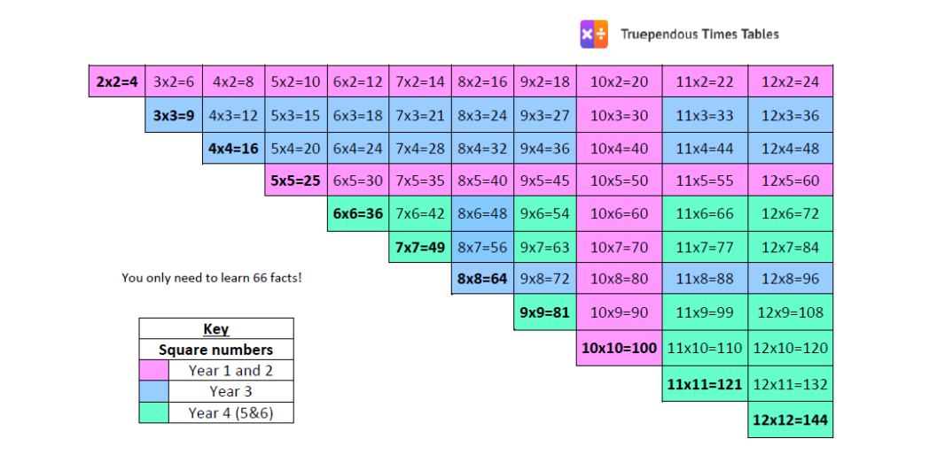 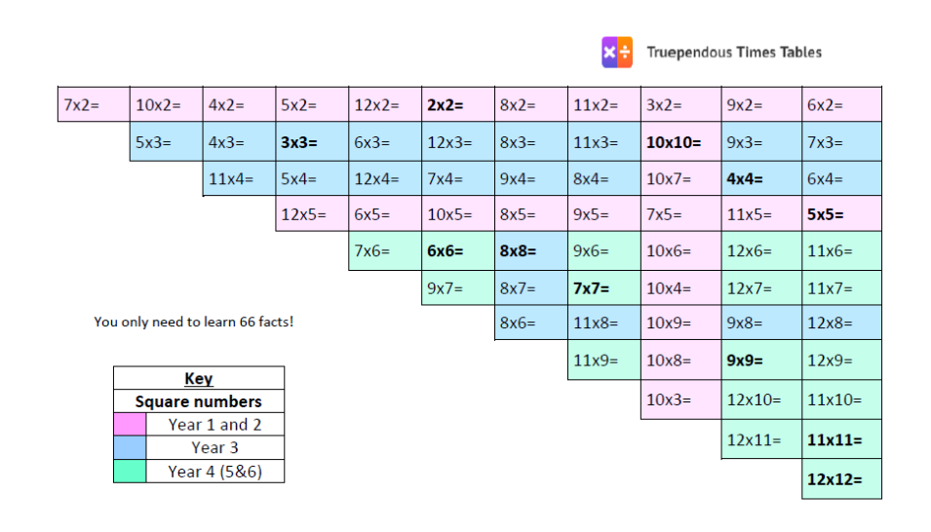

**This is a fantastic poster to show you don't need to know as many facts as you might first think! In fact, there are just 66 :)**