Diverse Text List
Term | Autumn |  | Spring |  | Summer
Year Group | 1 | 2 | 1 | 2 | 1 | 2
Nursery | Whose Toes Are Those? - Jabari Asim  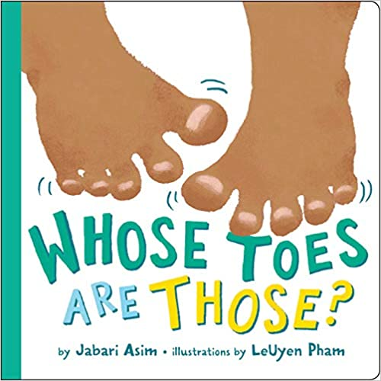 | Handa’s Surprise – Eileen Browne  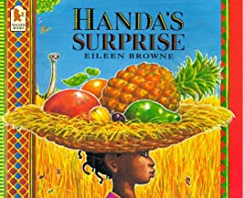 | Love Makes a Family – Sophie Beer  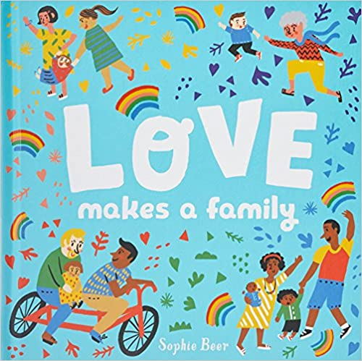 | All Are Welcome – Alexandra Penfold  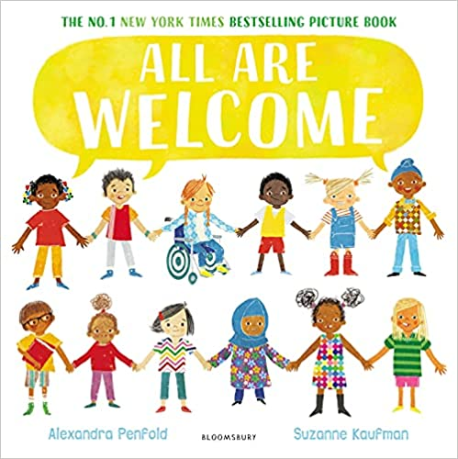 | Baby Goes to Market - Atinuke  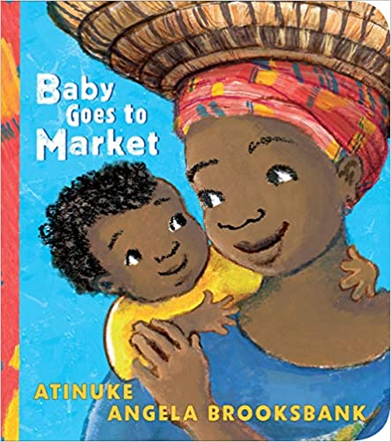 | Hats of Faith - Medeia Cohan  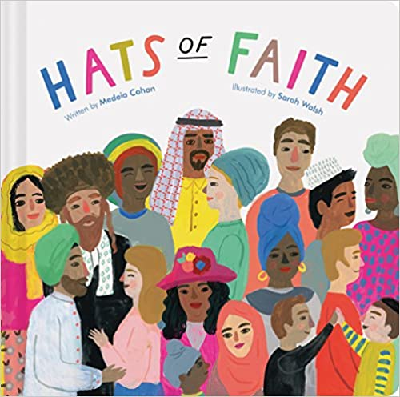
Reception | Hair Love – Matthew A Cherry  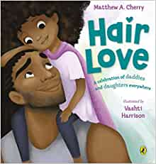 | My Dad is a Grizzly Bear – Swapna Haddow  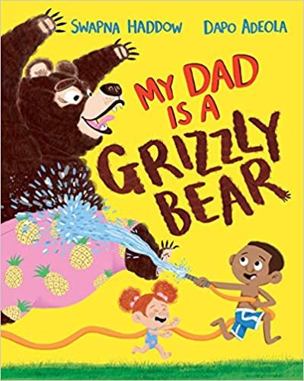 | We’re Going to Find a Monster – Malorie Blackman  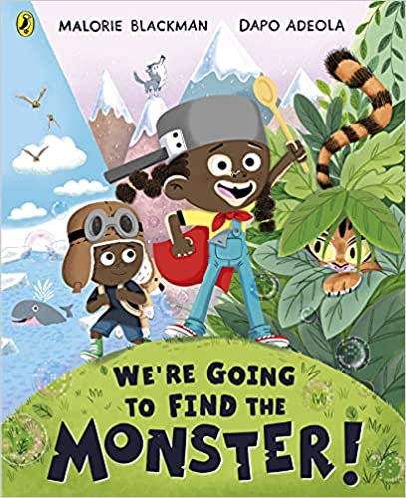 | M is for Melanin: A Celebration of the Black Child  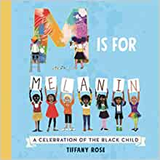 | Festival of Colours - Surishtha Sehgal  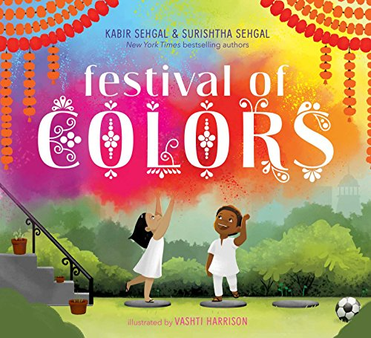 | Under the Love Umbrella – Davina Bell  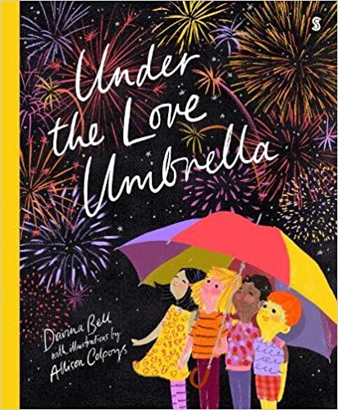
Year One | Ravi’s Roar - Tom Percival  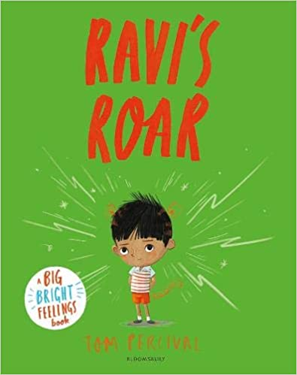 | Welcome to Our World – Moira Butterfield  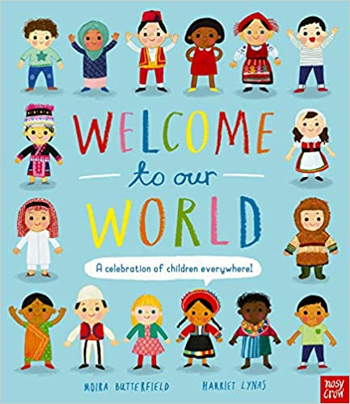 | Hue Boy – Rita Phillips Mitchell  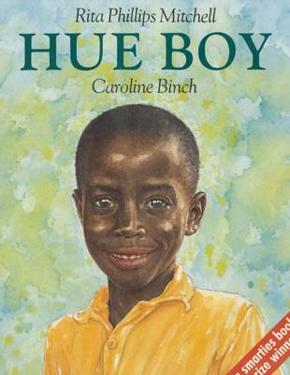 | Lubna and Pebble - Wendy Meddour  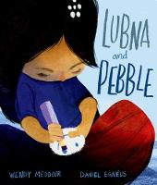 | This is How we Do it – Matt Lamothe  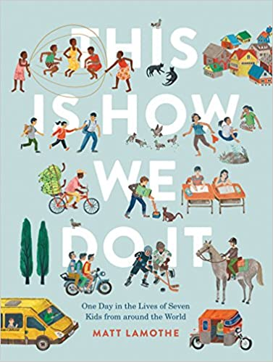 | Child of Galaxies – Blake Nuto  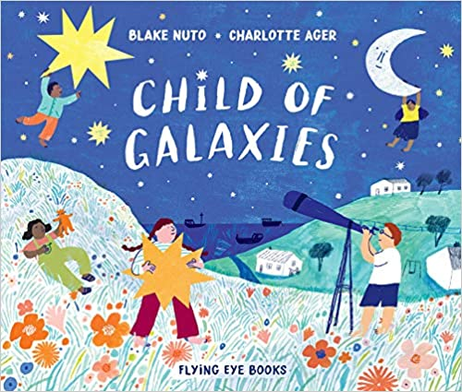
Year Two | Ruby’s Worry – Tom Percival  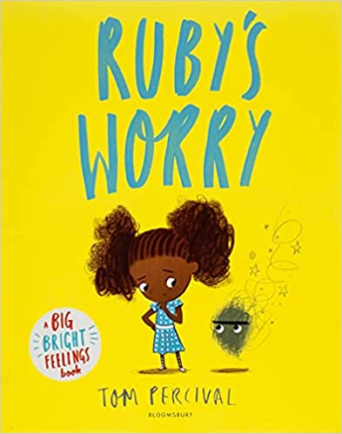 | Look Up – Nathan Bryon  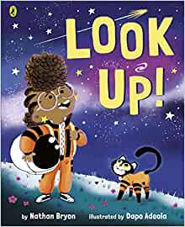 | Julian is a Mermaid – Jessica Love  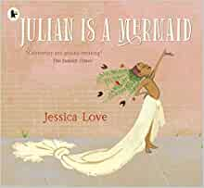 | Hey You! – Dapo Adeola  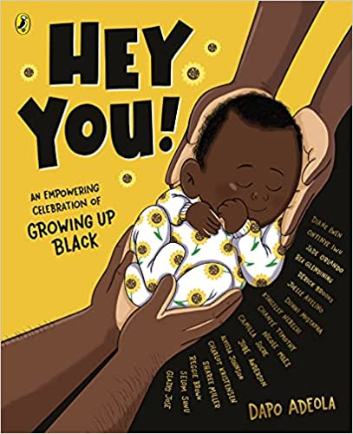 | All the Ways to be Smart – Davina Bell  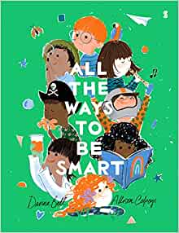 | The Proudest Blue – Ibtihaj Muhammad  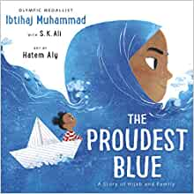
Year Three | Meesha Makes Friends – Tom Percival  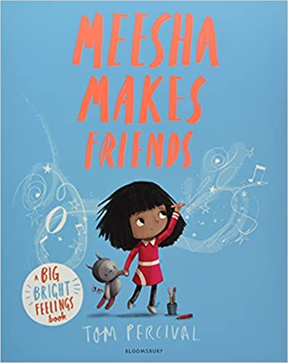 | Sofia Valdez, Future Prez – Andrea Beaty  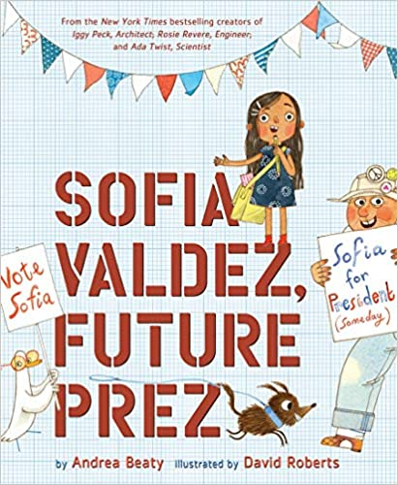 | Amazing Grace – Mary Hoffman  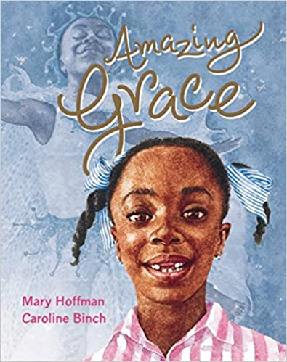 | Wigglesbottom Primary: Break-Time Bunnies – Pamela Butchart  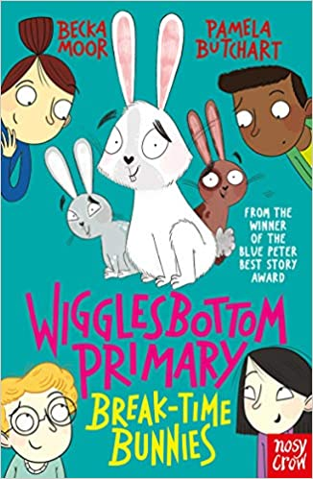 | Grandpa Bert and the Ghost Snatchers – Malorie Blackman  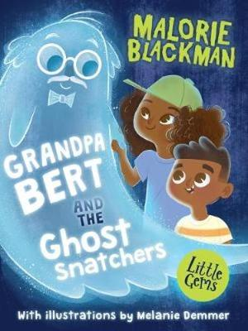 | Sulwe – Lupita Nyong'o  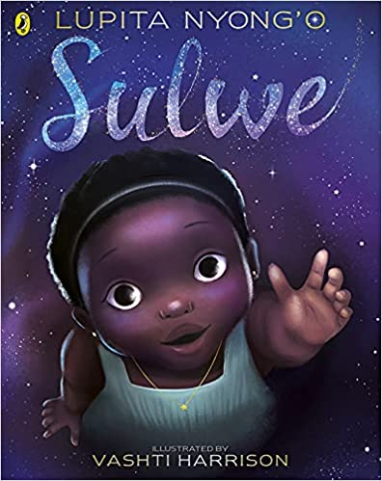
Year Four | Cookie! – Konnie Huq  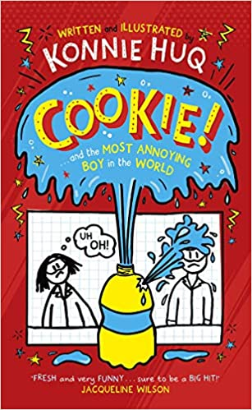 | Malala: My Story of Standing Up for Girls' Rights – Malala Yousafzai  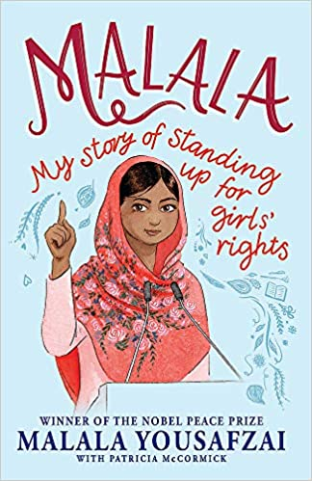 | Cece Loves Science - Kimberly Derting  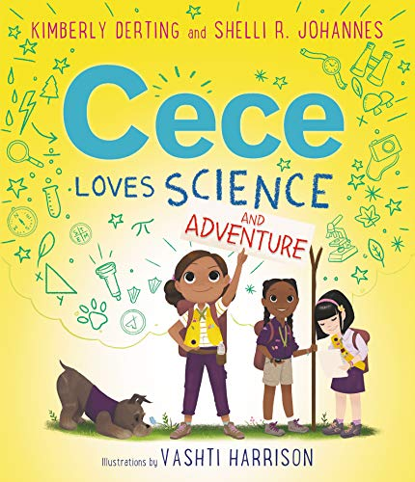 | Maya Angelou (Little Guides to Great Lives) – Danielle Jawando  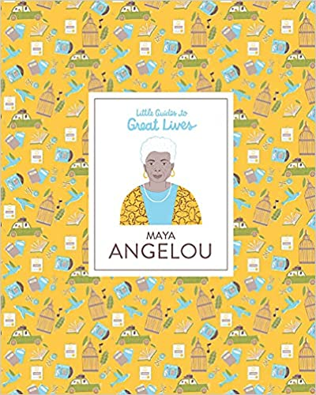 | Race to the Frozen North: The Matthew Henson Story – Catherine Johnson  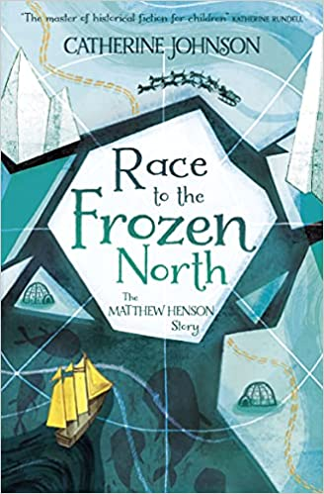 | Amari and the Night Brothers - BB Alston  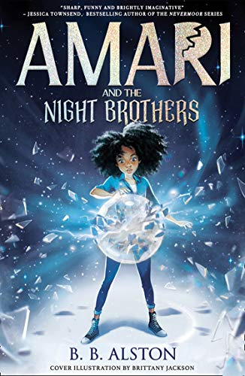
Year Five | When Stars are Scattered - Victoria Jamieson, Omar Mohamed  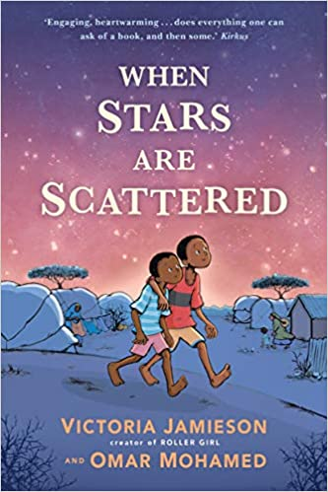 | The Boy at the Back of the Class - Onjali Rauf  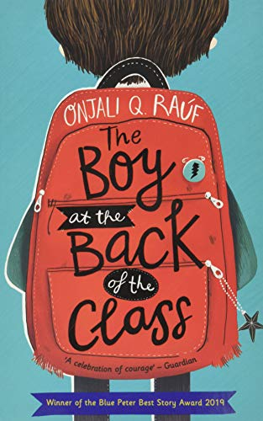 | The Night Bus Hero - Onjali Q. Rauf  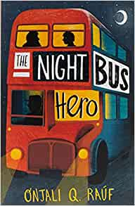 | A Dangerous Game – Malorie Blackman  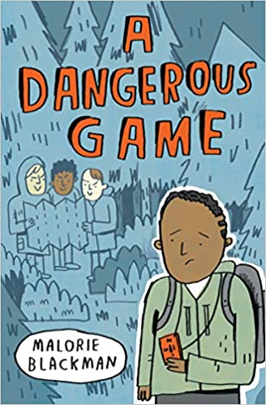 | The Girl Who Stole An Elephant – Nizrana Farook  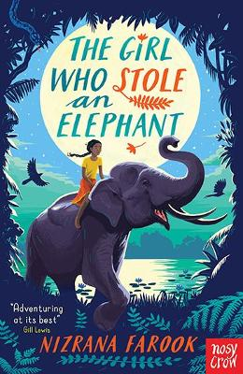 | The Star Outside My Window - Onjali Rauf  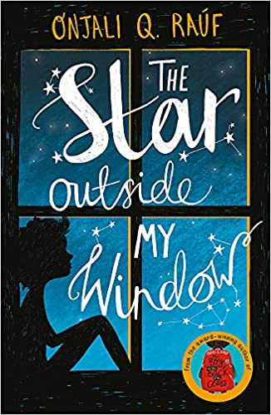
Year Six | The Garbage King – Elizabeth Laird  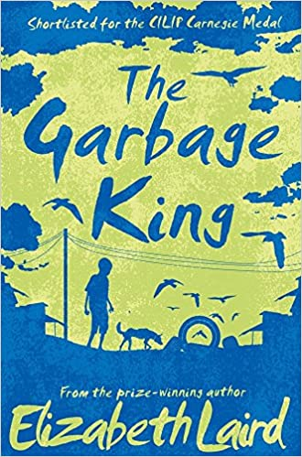 | The 1,000 Year Old Boy – Ross Welford  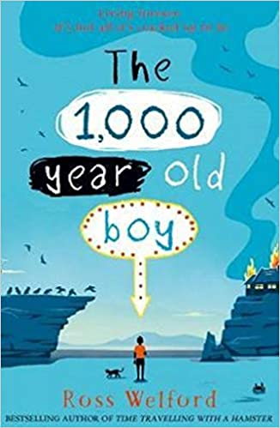 | Mohinder's War - Bali Rai  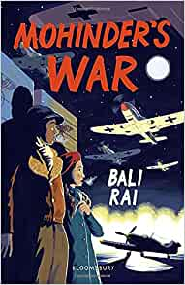 | Coming to England – Floella Benjamin  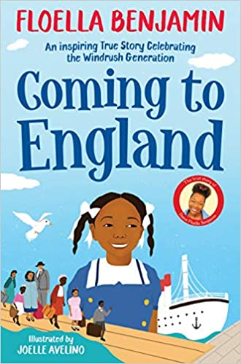 | Black and British – David Olusoga  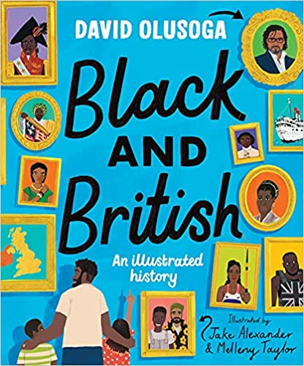 | A House Without Walls – Elizabeth Laird  