
Are you eligible to be a governor?

Please see the list below which details when a person is not eligible to serve as a school governor as laid down by School Governance (Constitution) (England) Regulations 2012 (regulation 17 and Schedule 4). Please read the form carefully.

If you are happy that none of the criteria apply to you, please sign and date the form and return it to the Headteacher for safekeeping in school.

If you are unsure whether you are eligible or not, please contact the Governor Support Service on 0113 3785213 for clarification

A person is disqualified from holding or from continuing to hold office as a governor or Associate Member if the person:
- Is the subject of a bankruptcy restrictions order or an interim order, debt relief restrictions order, an interim debt relief restrictions order or their estate has been sequestrated and the sequestration has not been discharged, annulled or reduced.

- Is subject to a disqualification order or disqualification undertaking under the Company Directors Disqualification Act 1986, a disqualification order under Part 2 of the Companies (Northern Ireland) Order 1989, a disqualification undertaking accepted under the Company Directors Disqualification (Northern Irelan) Order 2002, or an order made under section 429(2)(b) of the Insolvency Act 1986 (failure to pay under county court administration order).

- Has been removed from the office of trustee for a charity by an order made by the Charity Commission or Commissioners or High Court on grounds of any misconduct or mismanagement in the administration of the charity, or under section 34 of the Charities and Trustee Investment (Scotland) Act 2005 from being concerned in the management or control of any body.

- Is included in the list of people considered by the Secretary of State as unsuitable to work with children or young people.

- Is barred from any regulated activity relating to children.

- Is subject to a direction of the Secretary of State under section 142 of the Education Act 2002 or section 128 of the Education and Skills Act 2008

- Is disqualified from working with children or from registering for child-minding or providing day care.

- Is disqualified from being an independent school proprietor, teacher or employee by the Secretary of State.

- Has been sentenced to three months or more in prison (without the option of a fine) in the five years before becoming a governor or since becoming a governor (subject to certain exceptions for overseas offences that do not correlate with a UK offence)

- Has received a prison sentence of two and a half years or more in the 20 years before becoming a governor (subject to certain exceptions for overseas offences that do not correlate with a UK offence)

- Has at any time received a prison sentence of five years or more (subject to certain exceptions for overseas offences that do not correlate with a UK offence)

- Has been fined for causing a nuisance or disturbance on school or educational premises during the five years prior to or since appointment or election as a governor.

- Refuses a request by the clerk to make an application to the Disclosure and Barring Service for a criminal records certificate.

- Has been removed from a governing body during their term as an elected parent or staff governor within the last five years (from date of removal).

I confirm that I am eligible to be a school governor. I do not fulfil any of the above disqualification criteria.
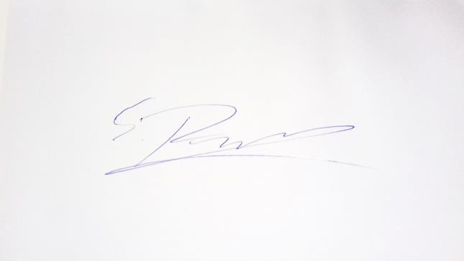
Signature Date ……………….. Name: ………………………………
Governing Body:

