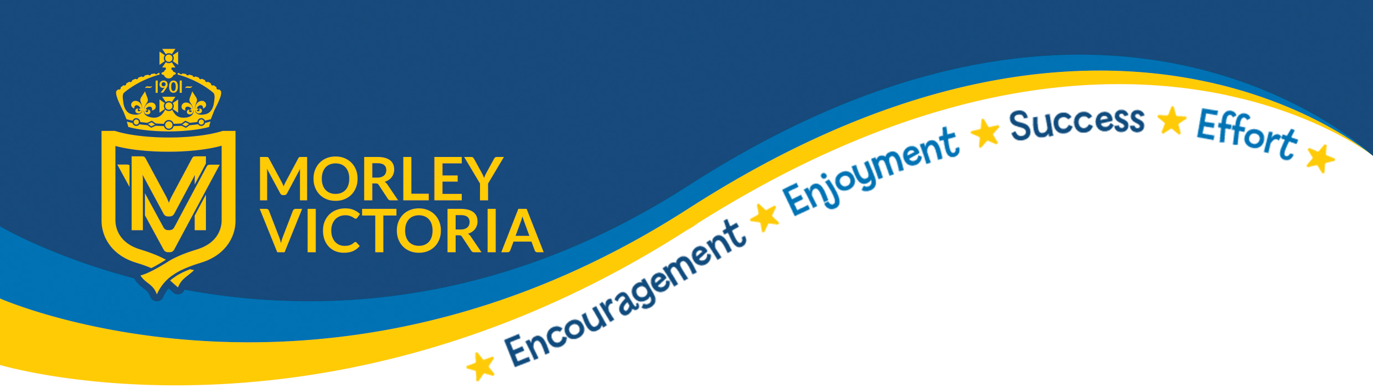

Age-related expectations to be achieved by the end of Early Years Foundation Stage
(For more detailed plans and information please see the curriculum section of our school website)
Communication and Language
In this area of the curriculum we are learning to listen, attend and understand language and to use language in order to speak correctly.

Is your child able to:
- Listen attentively and respond to what they hear with relevant questions, comments and actions when being read to and during whole class discussions and small group interactions.
- Make comments about what they have heard and ask questions to clarify their understanding.
- Hold conversation when engaged in back-and-forth exchanges with their teacher and peers.
- Participate in small group, class and one-to-one discussions, offering their own ideas, using recently introduced vocabulary.
- Offer explanations for why things might happen, making use of recently introduced vocabulary from stories, non-fiction, rhymes and poems when appropriate.
- Express their ideas and feelings about their experiences using full sentences, including use of past, present and future tenses and making use of conjunctions, with modelling and support from their teacher.

Personal. Social and Emotional Development (PSED)
In this area of the curriculum we are learning to self-regulate our feelings and emotions, manage our self and behaviour and build relationships with others.

Is your child able to:
- Show an understanding of their own feelings and those of others, and begin to regulate their behaviour accordingly
- Set and work towards simple goals, being able to wait for what they want and control their immediate impulses when appropriate
- Give focused attention to what the teacher says, responding appropriately even when engaged in activity, and show an ability to follow instructions involving several ideas or actions.
- Be confident to try new activities and show independence, resilience and perseverance in the face of challenge
- Explain the reasons for rules, know right from wrong and try to behave accordingly
- Manage their own basic hygiene and personal needs, including dressing, going to the toilet and understanding the importance of healthy food choices.
- Work and play cooperatively and take turns with others.
- Form positive attachments to adults and friendships with peers.
- Show sensitivity to their own and to others’ needs.

Physical Development
In this area of the curriculum we are learning to move confidently in large and small scale movements.

Is your child able to:
- Negotiate space and obstacles safely, with consideration for themselves and others.
- Demonstrate strength, balance and coordination when playing.
- Move energetically, such as running, jumping, dancing, hopping, skipping and climbing.
- Hold a pencil effectively in preparation for fluent writing – using the tripod grip in almost all cases.
- Use a range of small tools, including scissors, paint brushes and cutlery.
- Begin to show accuracy and care when drawing.

Understanding the World
In this area of the curriculum we are learning about the past and present, people, culture and communities and the natural world around us.

Is your child able to:
- Talk about the lives of the people around them and their roles in society.
- Know some similarities and differences between things in the past and now, drawing on their experiences and what has been read in class.
- Understand the past through settings, characters and events encountered in books read in class and storytelling.
- Describe their immediate environment using knowledge from observation, discussion, stories, non-fiction texts and maps.
- Know some similarities and differences between different religious and cultural communities in this country, drawing on their experiences and what has been read in class.
- Explain some similarities and differences between life in this country and life in other countries, drawing on knowledge from stories, non-fiction texts and – when appropriate – maps.
- Explore the natural world around them, making observations and drawing pictures of animals and plants.
- Know some similarities and differences between the natural world around them and contrasting environments, drawing on their experiences and what has been read in class.
- Understand some important processes and changes in the natural world around them, including the seasons and changing states of matter.

Expressive Arts and Design
In this area of the curriculum we are learning to create and explore media and materials and to be imaginative and expressive.

Is your child able to:
- Safely use and explore a variety of materials, tools and techniques, experimenting with colour, design, texture, form and function.
- Share their creations, explaining the process they have used.
- Make use of props and materials when role playing characters in narratives and stories.
- Invent, adapt and recount narratives and stories with peers and their teacher.
- Sing a range of well-known nursery rhymes and songs.
- Perform songs, rhymes, poems and stories with others, and – when appropriate – try to move in time with music.

