

cROSS CURRICULAR WORK



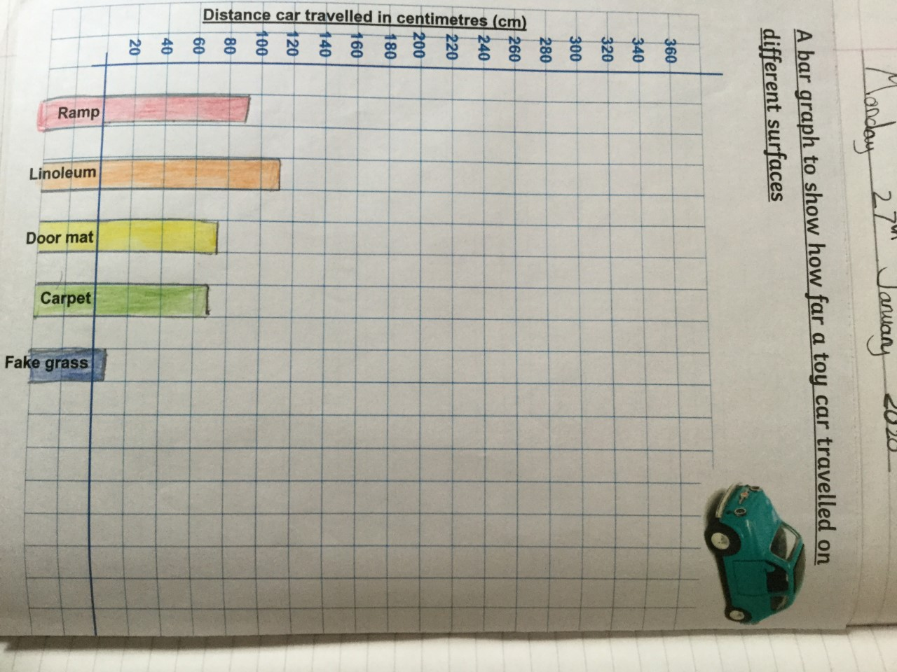
SCIENCE
BAR GRAPH

SCIENCE
VENN DIAGRAM

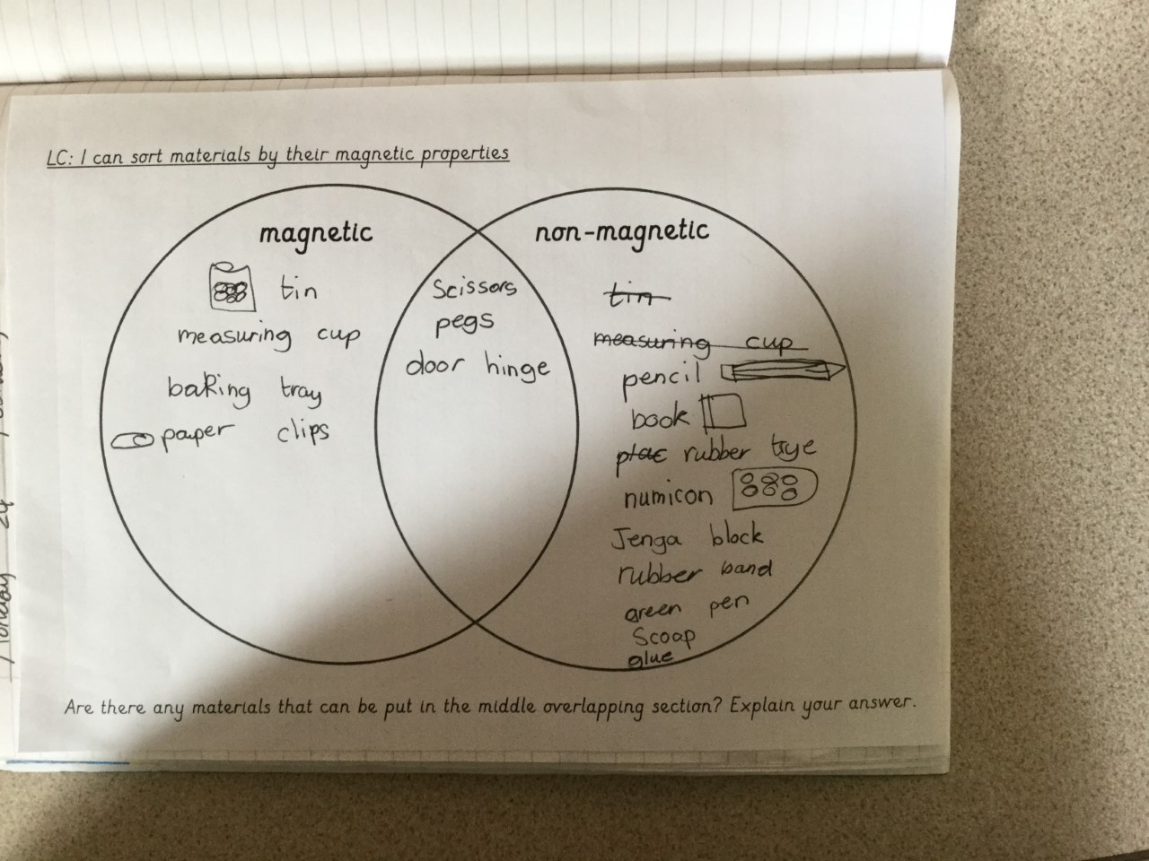

GEOGRAPHY
CO-ORDINATES

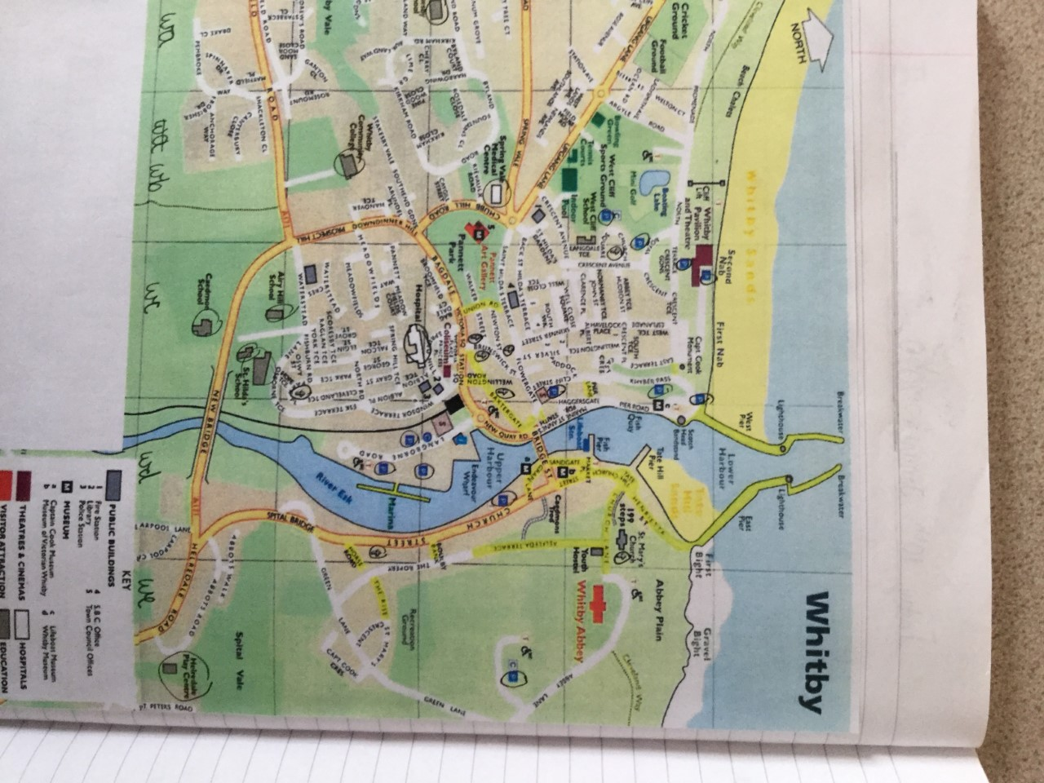

SCIENCE
MEASUREMENT

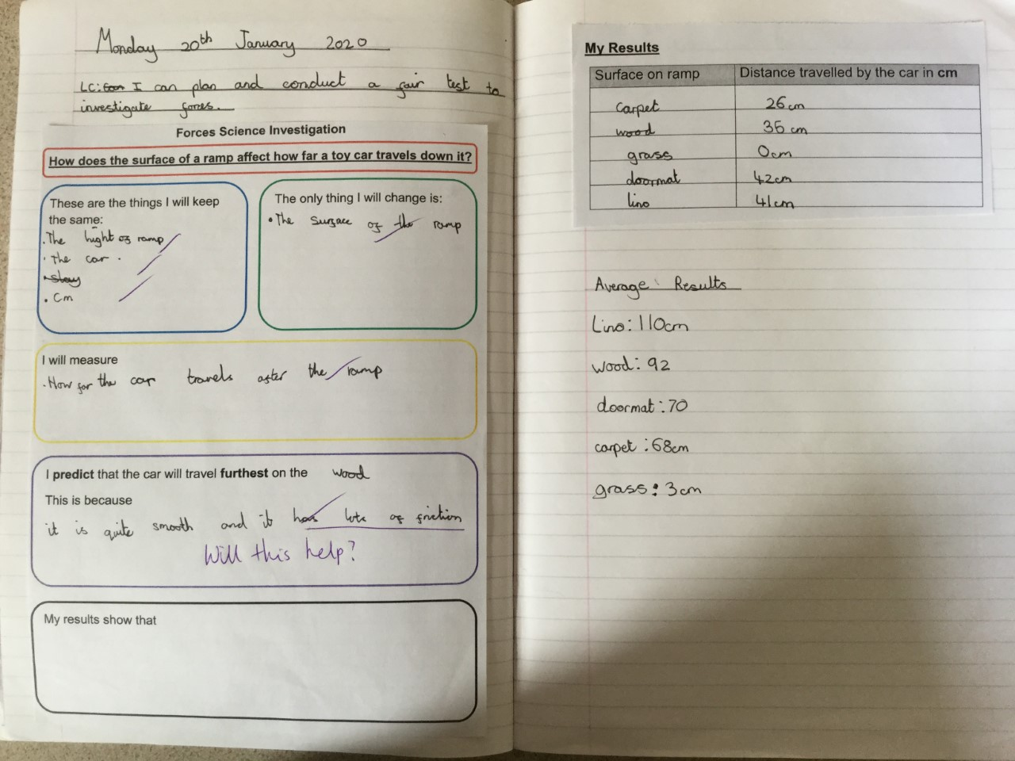

GEOGRAPHY
BAR GRAPH

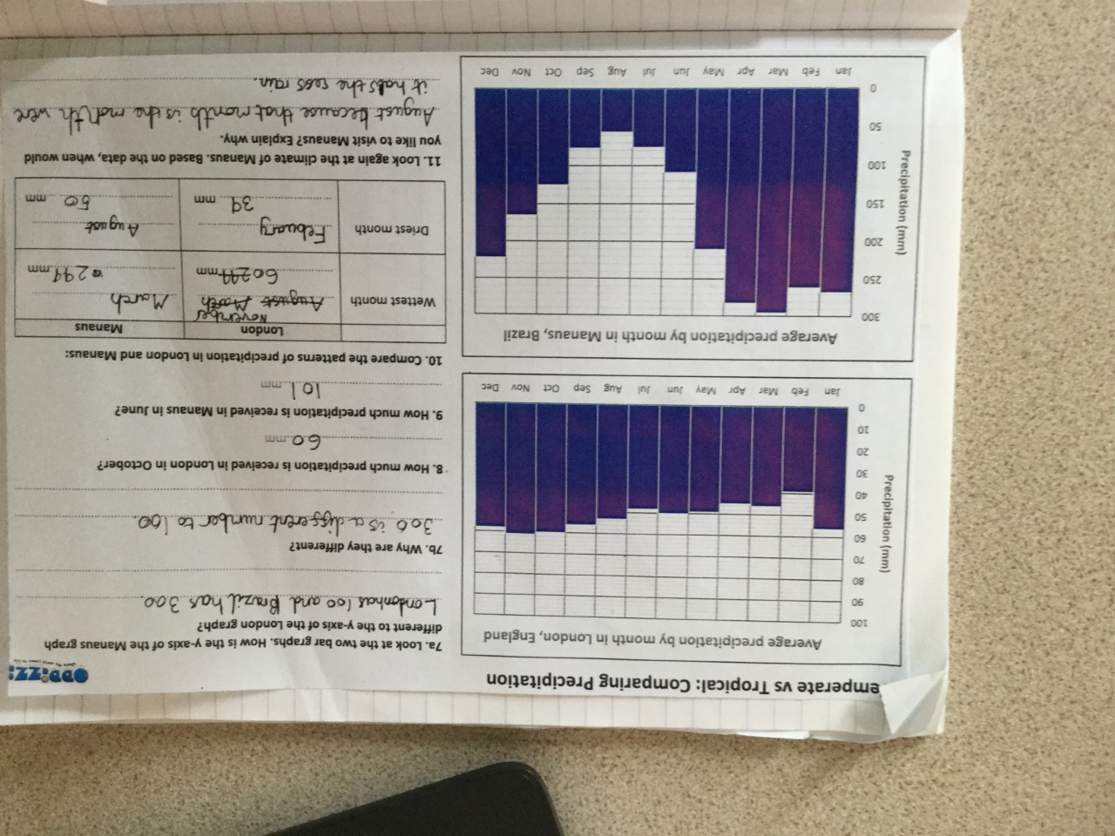

GEOGRAPHY
LINE GRAPH

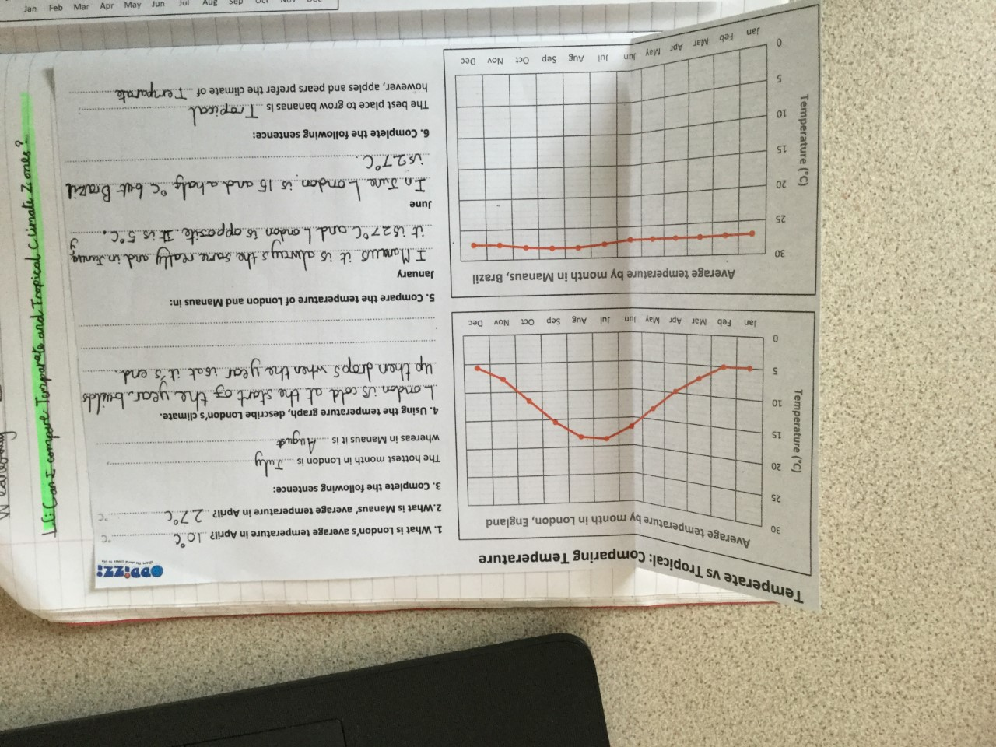

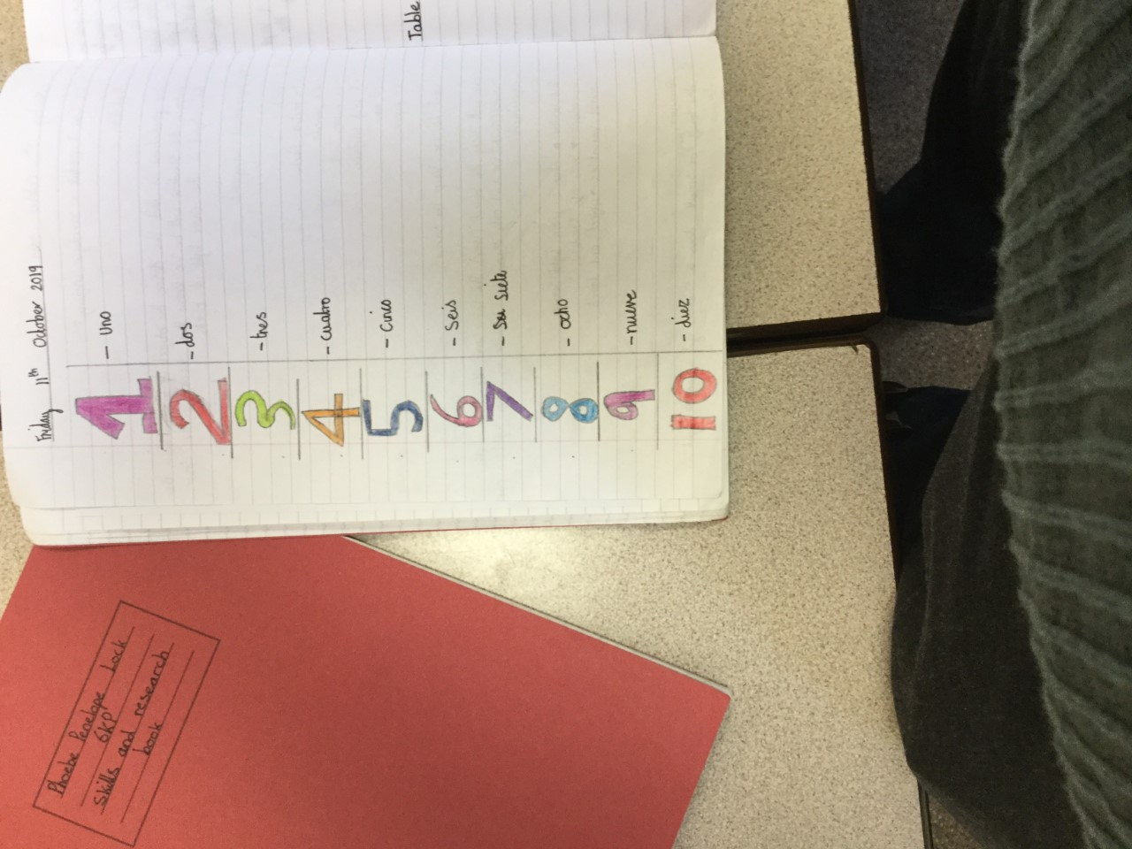
MFL
NUMBER

SCIENCE
MEASUREMENT

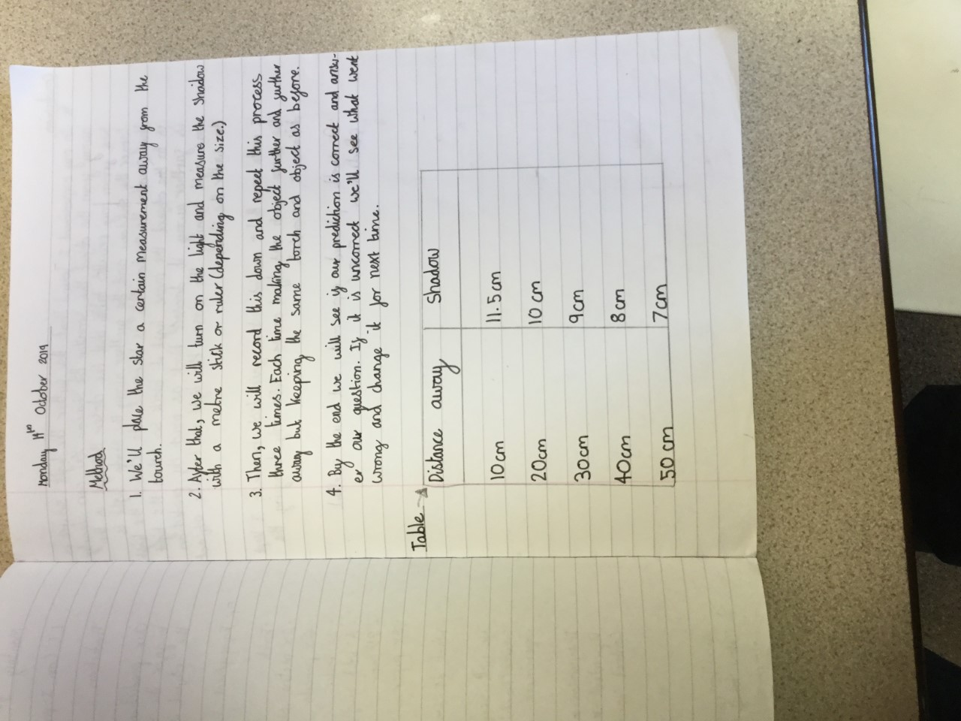

HISTORY
AREA AND PERIMETER

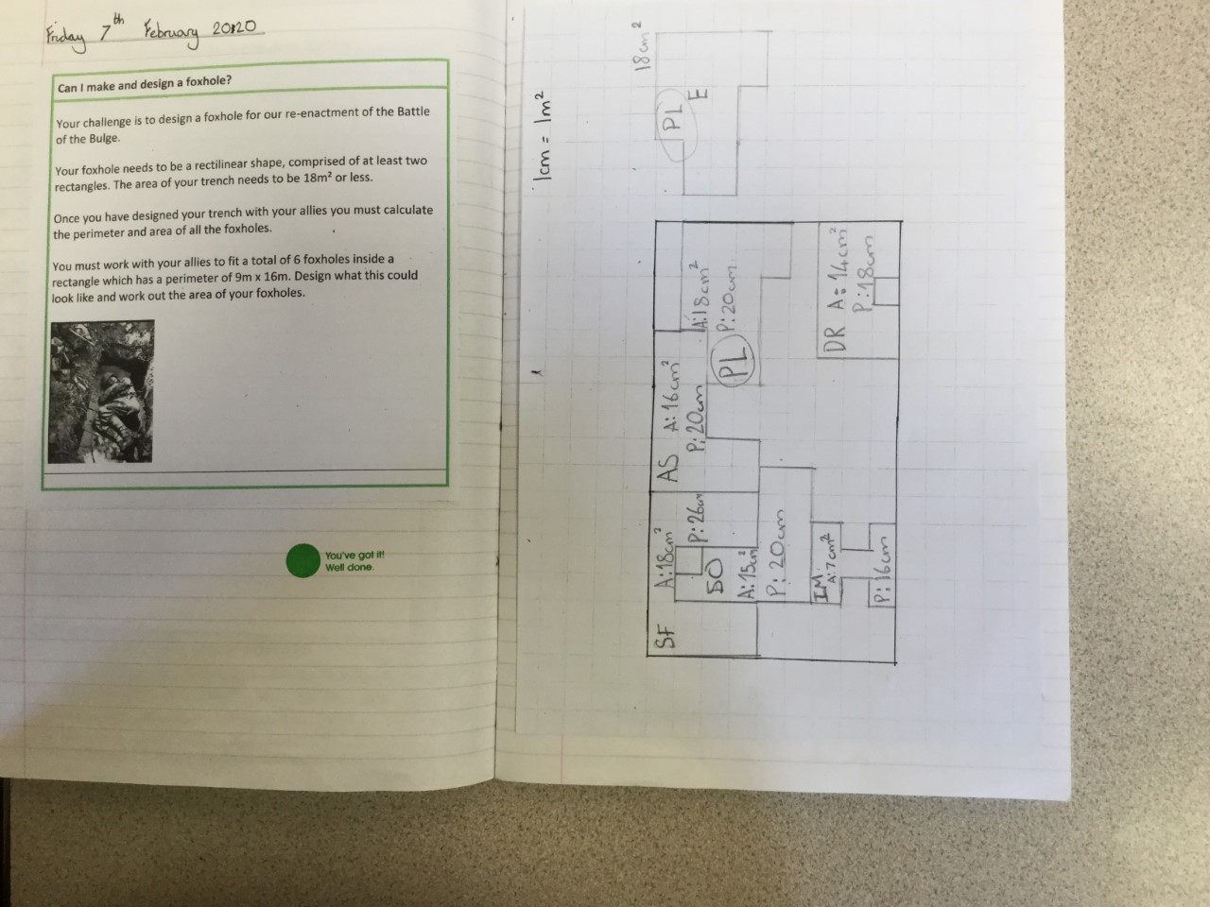

HISTORY
VENN DIAGRAM

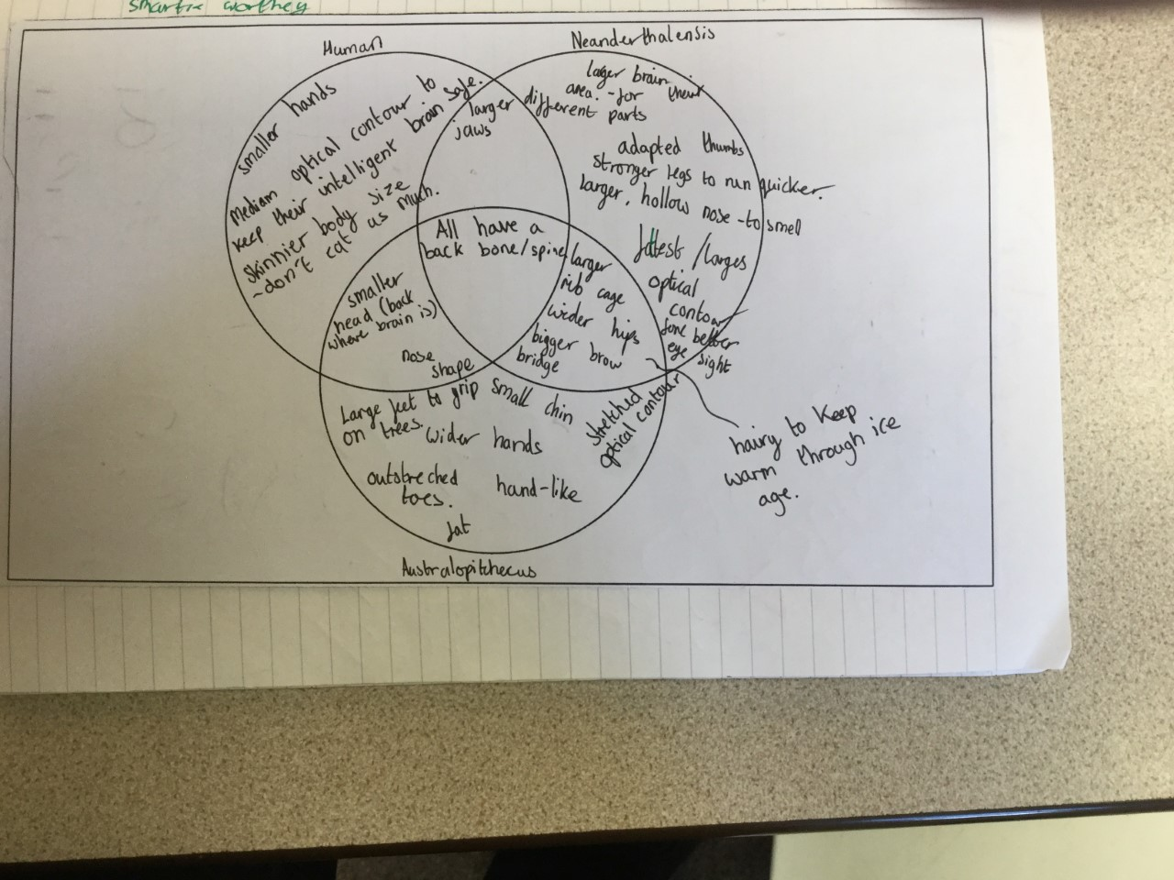

SCIENCE
USING A PROTRACTOR

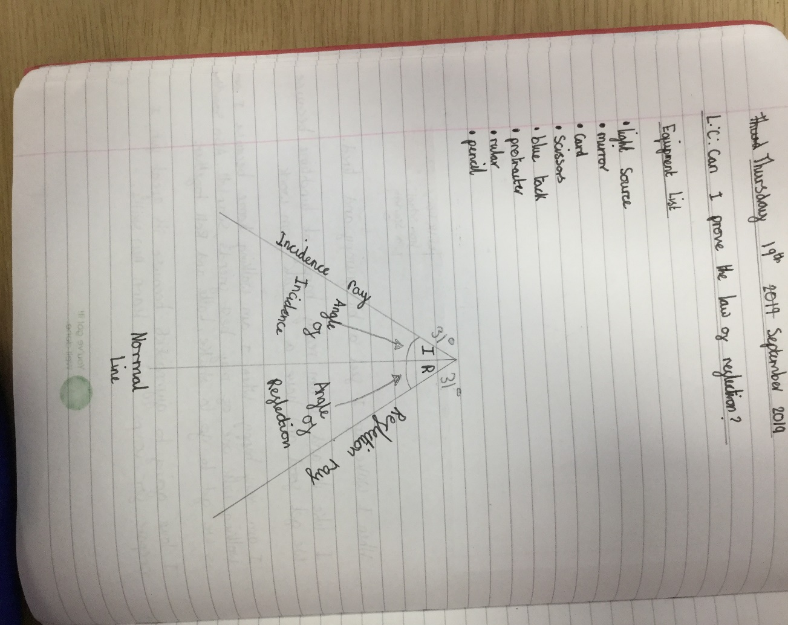

COMPUTING
AVERAGES

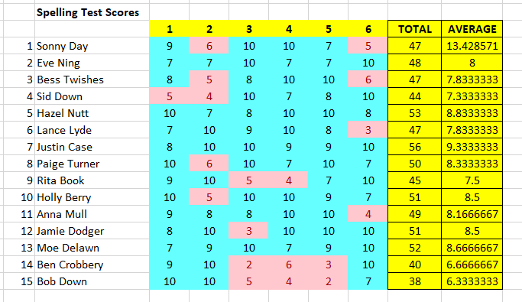

COMPUTING
FORMULAS AND MONEY

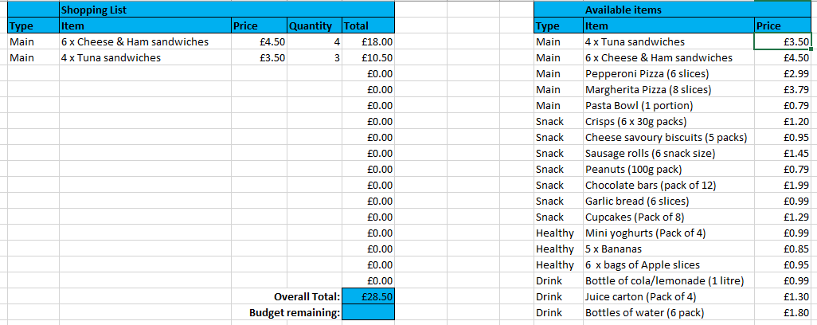

COMPUTING
POSITION AND DIRECTION



PSHE
VENN DIAGRAM

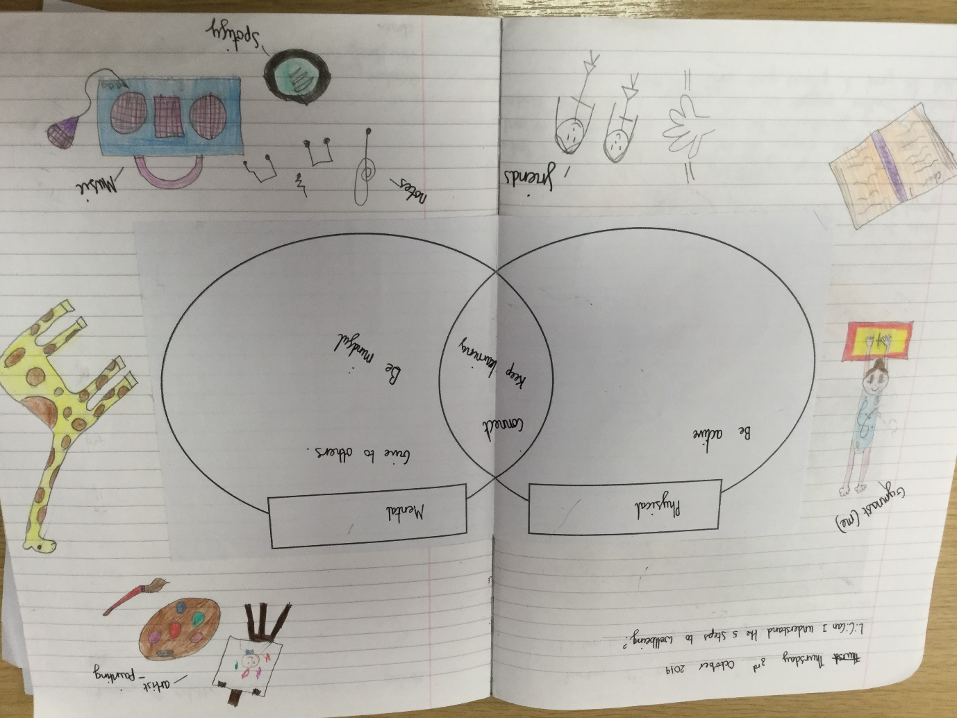

HISTORY
SCALE FACTOR AND ORDERING

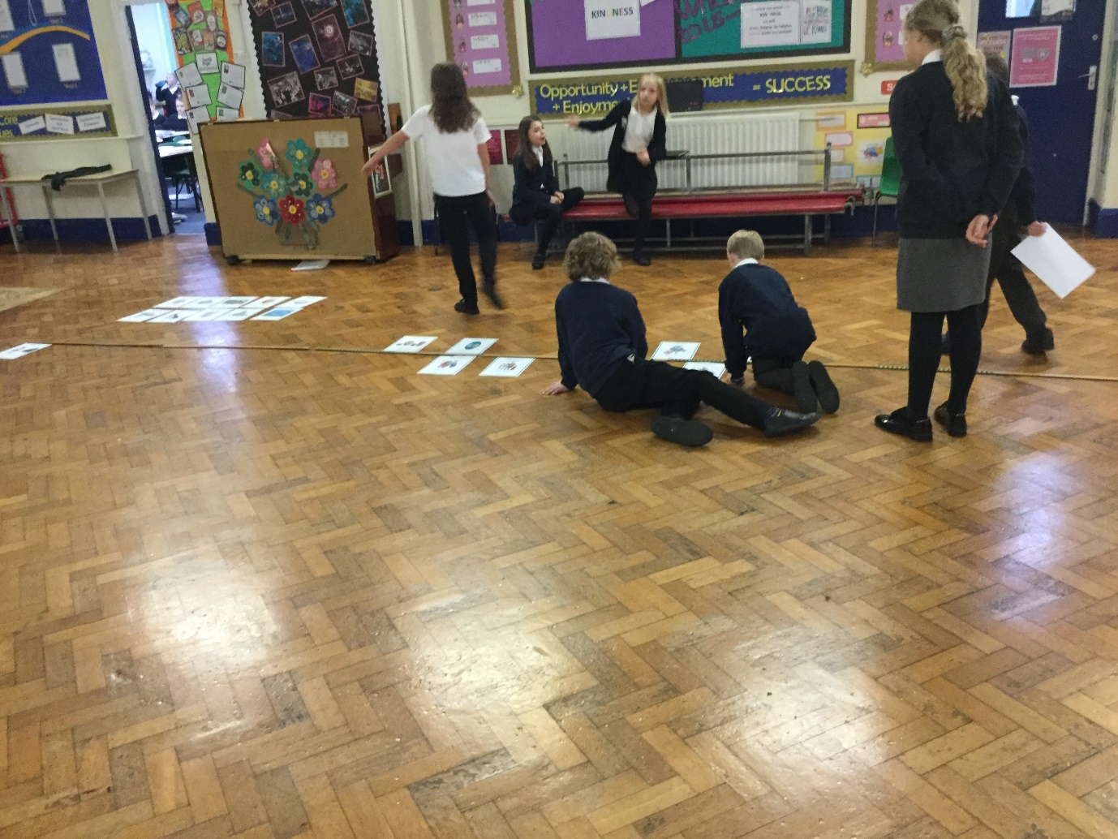

SCIENCE
STATISTICS & MEASUREMENTS

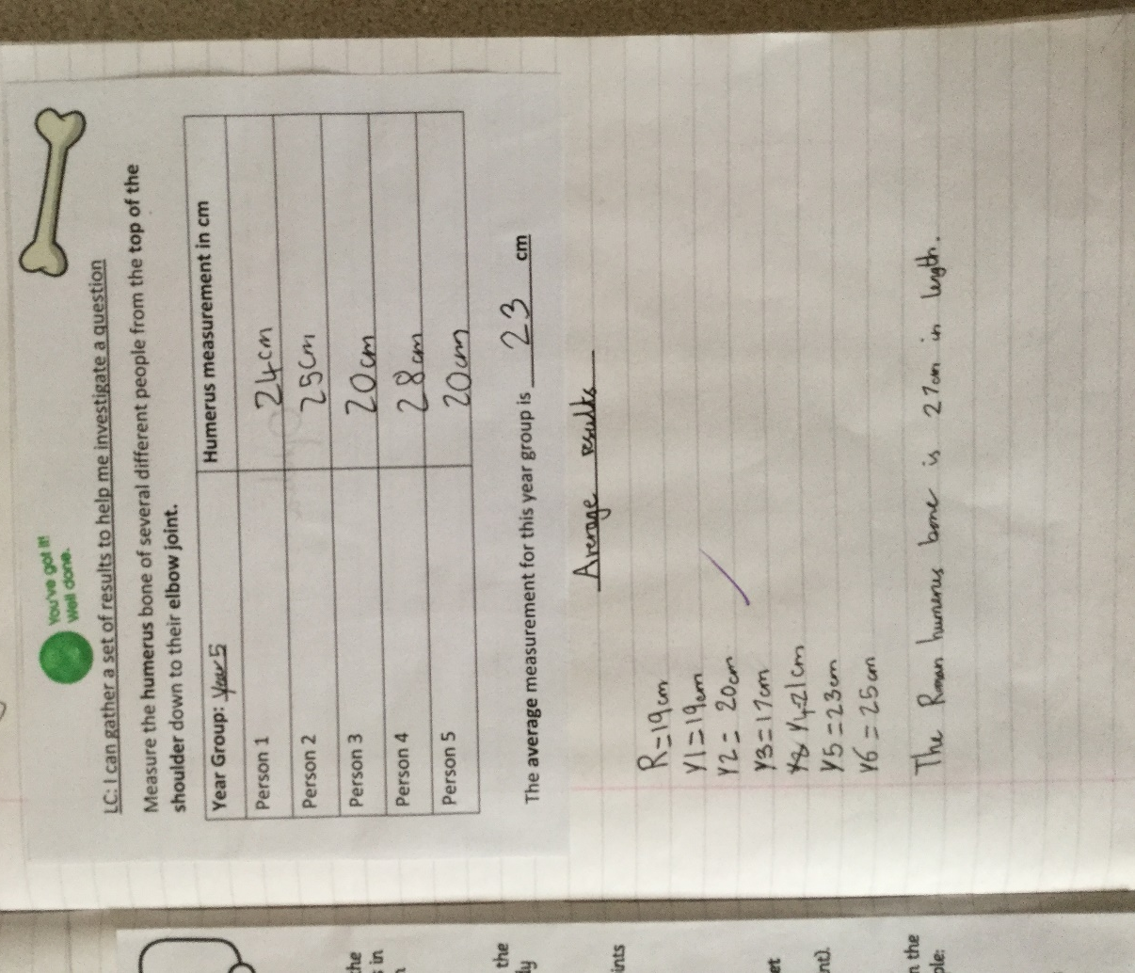

SCIENCE
BAR GRAPH

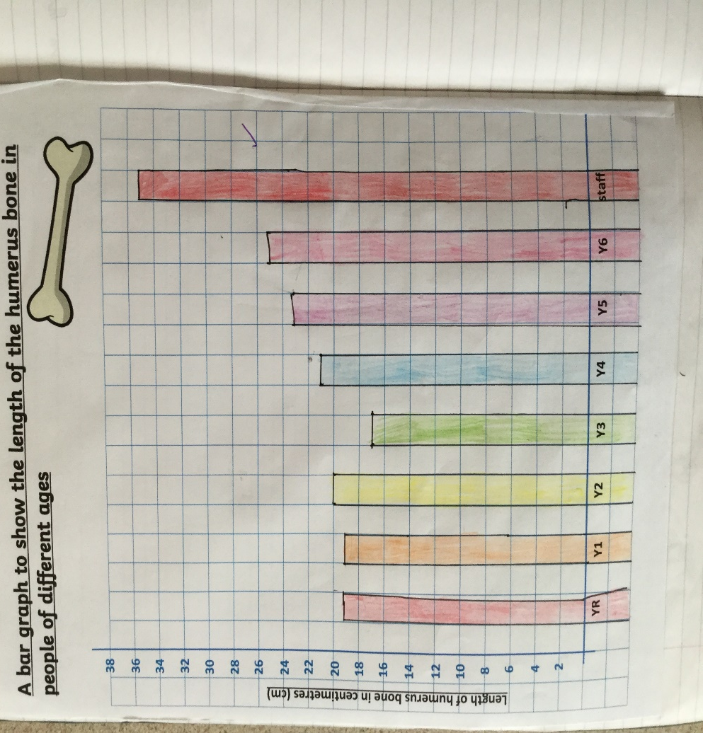

GEOGRAPHY
POSITION AND DIRECTION

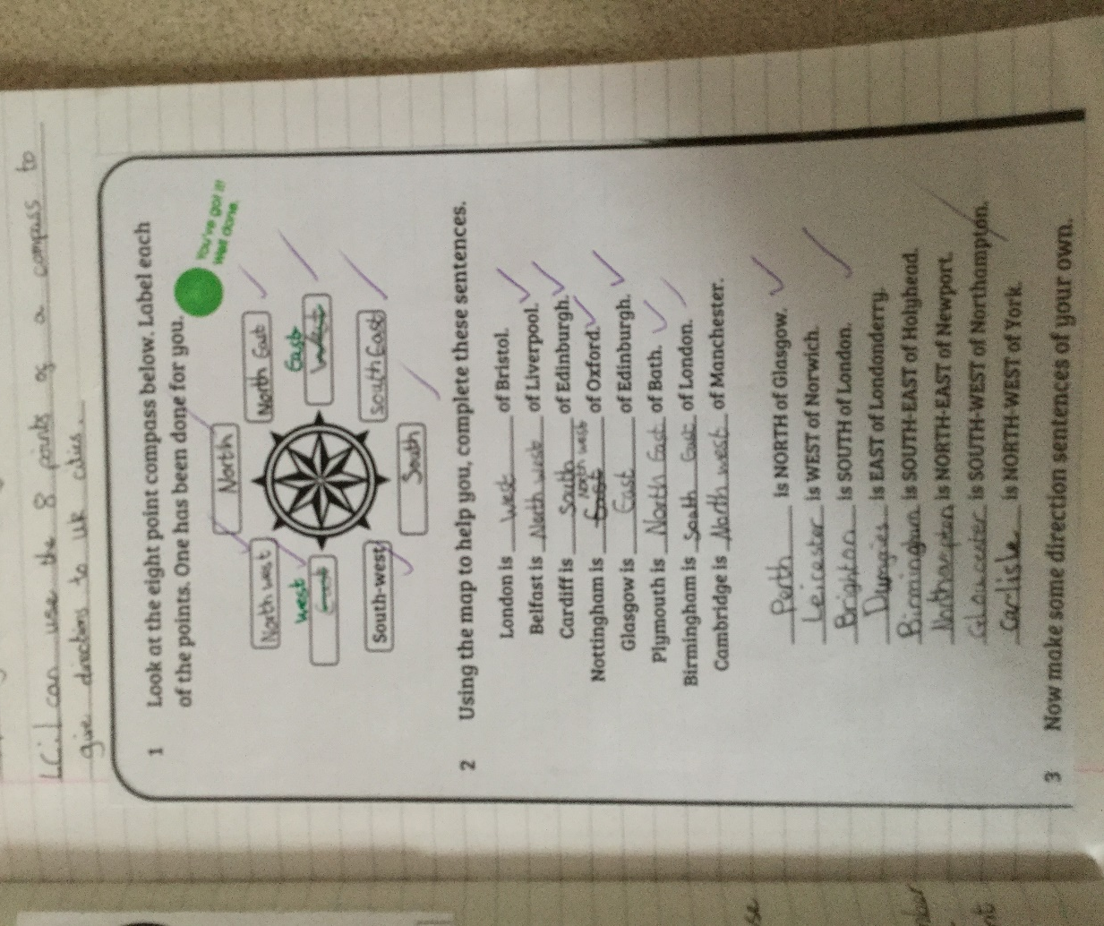

MFL
NUMBER

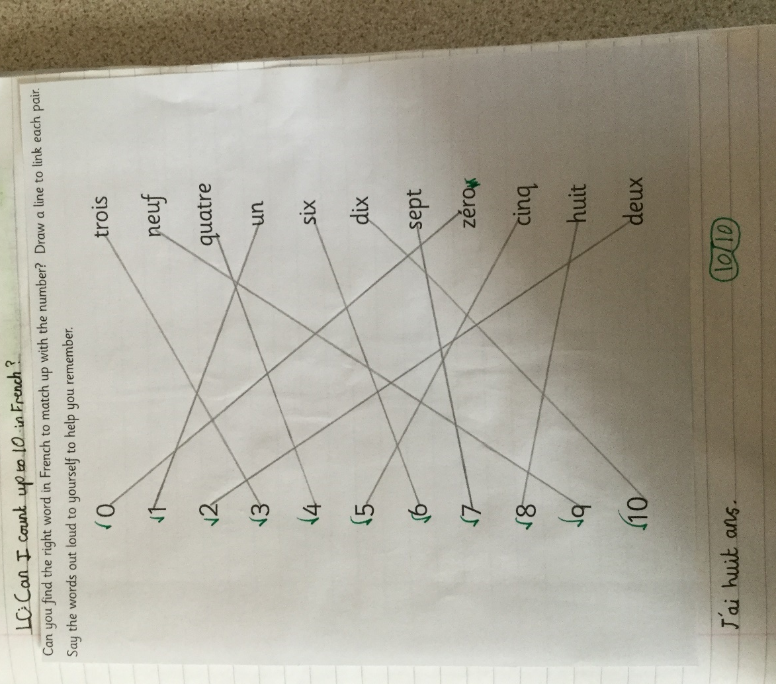

PSHE
MONEY AND ECONOMICS

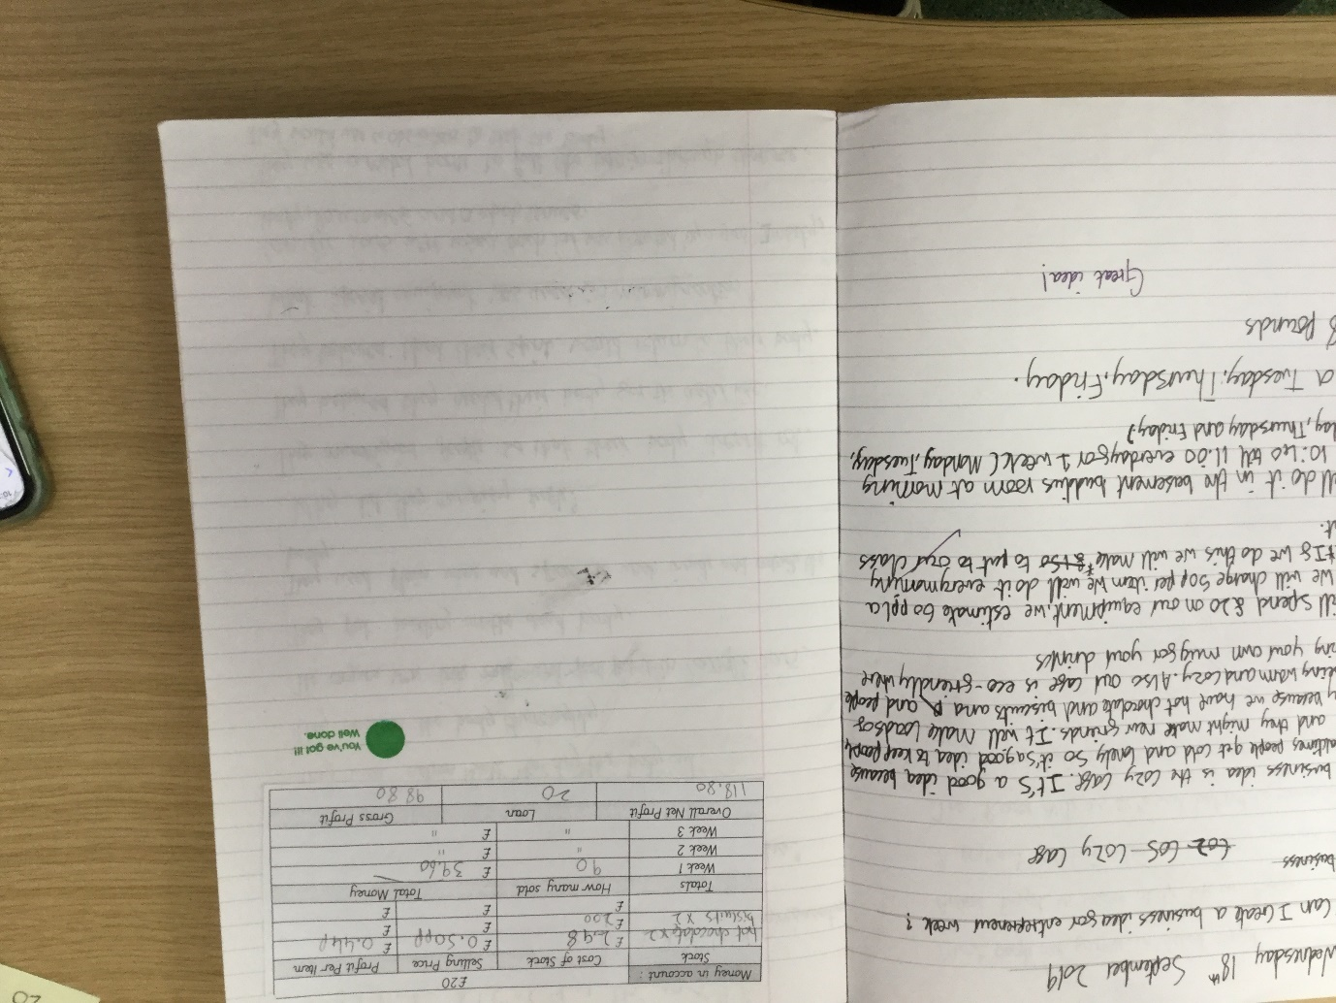

PSHE
MONEY AND ECONOMICS

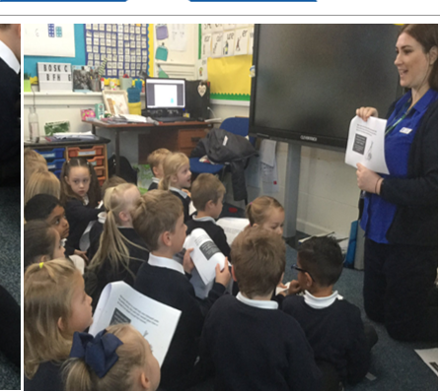

DESIGN TECHNOLOGY
MEASUREMENTS




P.E.
MENTAL CALCULATIONS


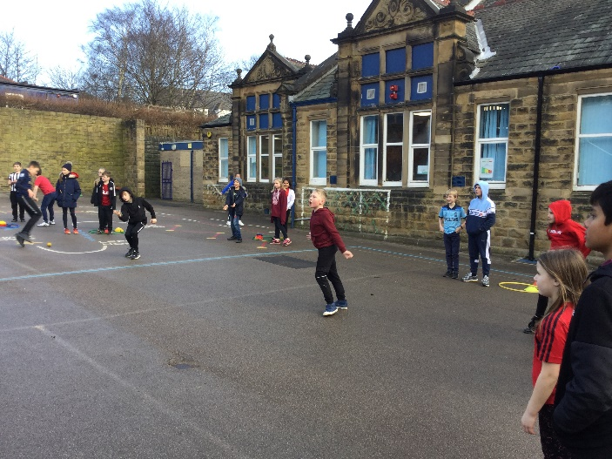

PSHE
PROBLEM SOLVING


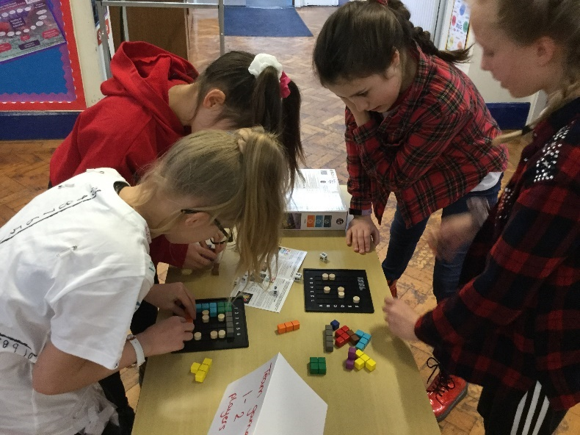

HISTORY
ORDERING

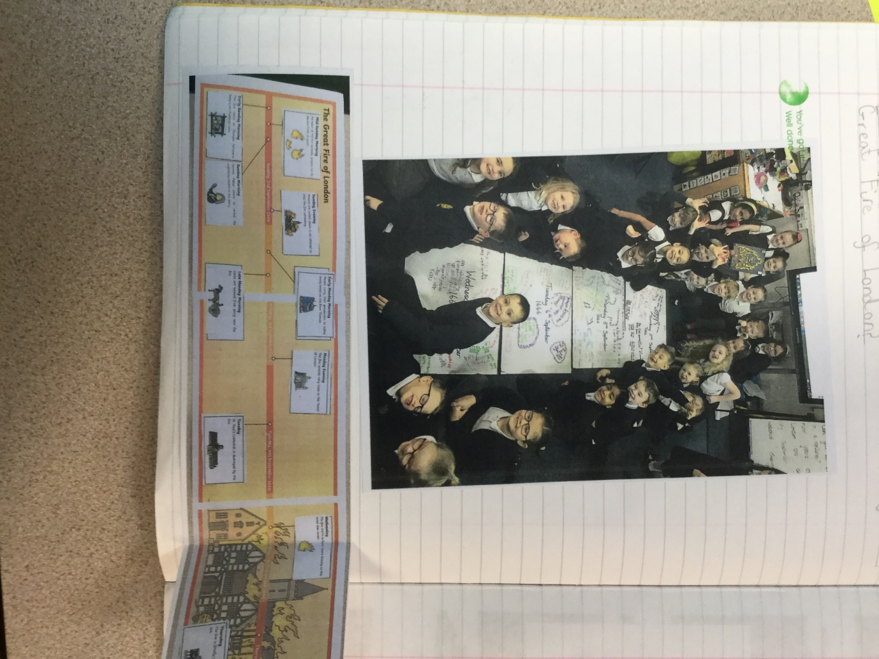

GEOGRAPHY
POSITION AND DIRECTION

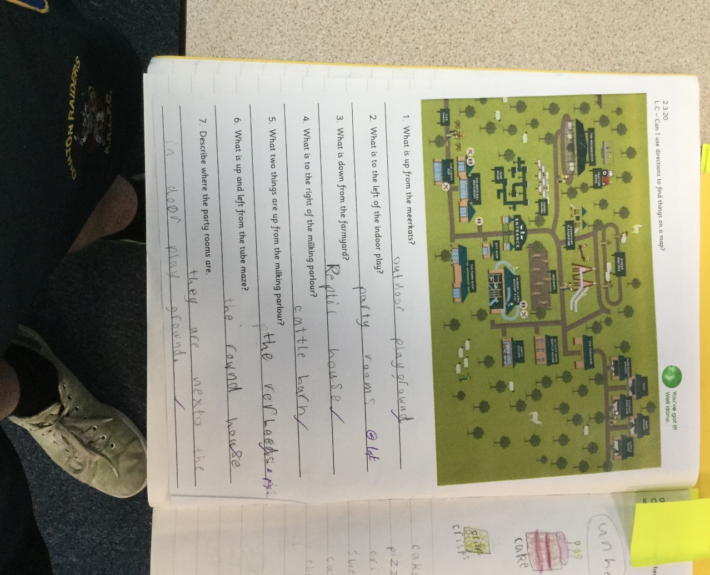

SCIENCE
BAR CHARTS

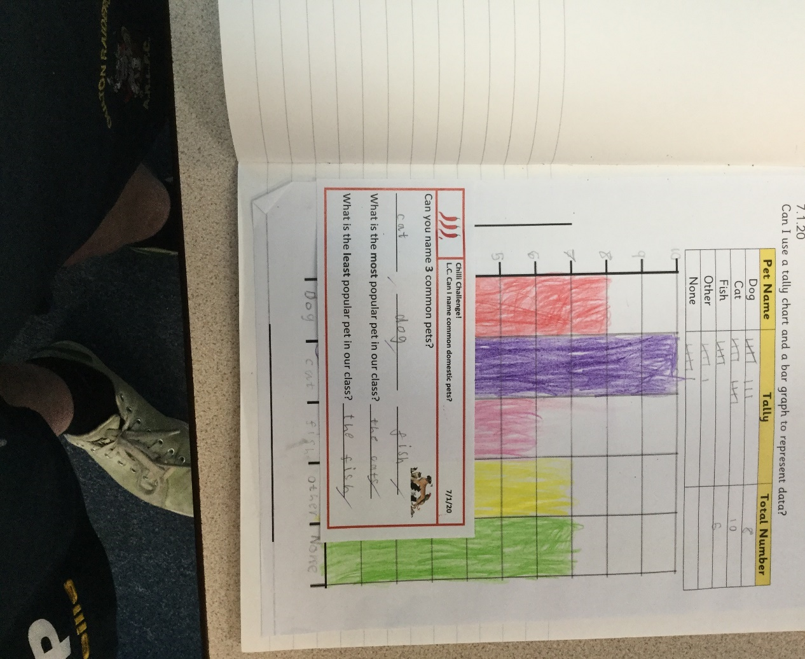

SCIENCE
PICTOGRAM



