Computing and Online Safety in EYFS

Computing and computational thinking knowledge, understanding and skill development in EYFS is taught under many areas of Development Matters. It is crucial that we ensure they receive the key messages surrounding this subject so that they are safe online. Computing is taught by exploring and playing in purposeful well thought out areas of provision, through active learning and through creating and thinking critically.

In EYFS the children:
- Explore how things work.
- Investigate a range of media.
- Develop computational thinking.
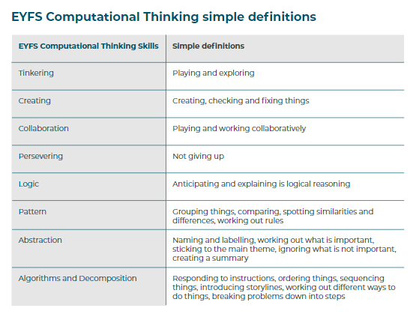
Their learning provides children with a solid base to allow them to access the National Curriculum in Year 1.

Skill/activity focus: | Early Learning Goal
Access to a variety of working and broken electronic devices and toys within provision | Understanding the world (linked to things from the past)
Moving robots (Colby Mice) | Maths (positional language)
Creating art on the iPad | Expressive arts and design
Using voice recorders within provision | Communication and language
Keyboards (unplugged in the classroom) | Literacy and physical development
Taking photos | Exploring the world

Computing Long Term Plan |  |  |  |  |  | 
Year Group | Autumn 1 | Autumn 2 | Spring 1 | Spring 2 | Summer 1 |  | Summer 2
Reception | Using technology within provision  Computational Thinking Skills in EYFS  Classroom | Using technology within provision  Computational Thinking Skills in EYFS  Classroom | Using technology within provision  Computational Thinking Skills in EYFS  Classroom | Using technology within provision  Computational Thinking Skills in EYFS  Classroom | Programming – Moving a robot  Classroom – Code and Go Mouse |  | Taking photos  Digital painting Doodle Buddy app  iPads

Three stands of computing:
Digital Literacy
Information Technology
Computer Science

Online Safety
Online safety in EYFS is taught through stories and discussions when using devices within provision. Clear links will be made with topics and ensuring the learning is relevant to the children’s age and experiences.
Internet Safety Objectives EYFS | Term:
- Naming own work e.g. paintings and knowing that naming something means it belongs to you.  - “Stop I don’t like it” and how this applies to online as well as in real life | Autumn 1
- Ways that the internet can be used to communicate e.g. email, Whatsapp, Zoom  - How the internet can be used to find out information  - Devices that can be used to find out information | Autumn 2
- Learn own personal information about themselves e.g. age, name, address  - Identify who it is safe to share personal information with and why | Spring 1
- Rules that keep us safe and healthy when using technology  - Identify ways that people can be unkind online | Spring 2
Recapping of teacher assessed objectives  and a focus on computing skills (programming code&go) | Summer 1
Recapping of teacher assessed objectives  and a focus on computing skills (creating art on the ipads) | Summer 2



