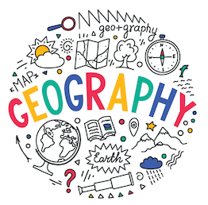
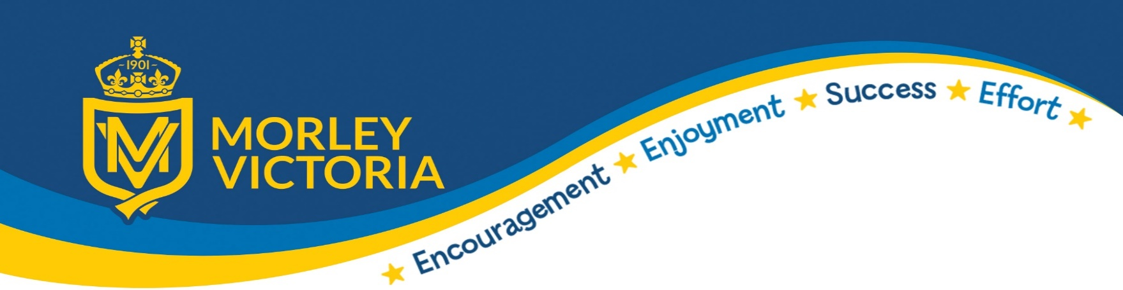


- Use reading lessons to consolidate learning
- Share the next steps in learning
- Celebrate the work completed e.g. presentations of learning, parents showcase, share with other year groups etc
- Plan to address and revisit any common misconceptions from previous and current learning
- What skills and knowledge will be in your end of unit quizzes?
CONSOLIDATE
INTRODUCE
- Share the end points, purpose/hook
- Make links to existing, previous knowledge and real life context (schema) See LTP
- Retrieval practice (sticky knowledge)
- Introduce and revisit tier 3 vocabulary
- Specify the skill e.g. physical, human, locational or field/mapwork etc
- Knowledge Organiser



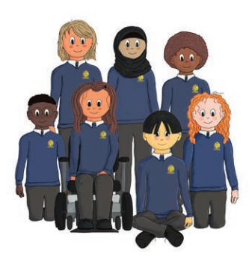

DEMONSTRATE

- Model the skill, vocabulary or use stem sentences to express views (shared or guided)
- Choose the correct way to present e.g. video, map work, aerial photographs, globes, a text or outdoor learning
- I do you do for skills e.g. map work, using a globe etc

ACTION
- Practical resources ready and hands on
- Scaffolded so all children can achieve the objective of the lesson – their recording may look different
- Individual, paired and group work
- Opportunity to apply or record their learning
- Teacher assessing learning throughout the lesson use of questioning
- Refer back to the skill focus of the lesson e.g. physical, human, locational or field/map work

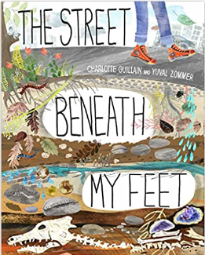
‘Learning geography requires students to read widely from a variety of texts and other sources of information. They need to select, compare, synthesise and evaluate information from different sources as well as use other skills to distinguish fact and opinion, and to recognise bias and objectivity in sources. Add to this the fact that geography has its own extensive vocabulary which needs to be mastered if students are to be able to understand and interpret what they are reading.’

READING AS A GEOGRAPHER

KEY KNOWLEDGE FOR A GEOGRAPHER
KEY SKILLS FOR A GEOGRAPHER
Knowledge of the Earth’s physical and human processes
Knowledge of people, places, resources, natural and human environments
Knowledge of their location in relation to the wider world

Question, analyse and explain findings
Fieldwork and techniques
Express balanced views about current issues in society and the environment

SUBSTANTATIVE OR DISCIPLINARY KNOWLEDGE
There is more to a subject than the information , facts and concepts that are taught and learned. These things are substantive knowledge. Disciplinary knowledge focuses on what it is like to be a geographer and what they actually do in order to preserve the discipline in their subject and make it more than just substantiative knowledge.

Substantive Knowledge– Is knowledge and ‘substance’ of our curriculum e.g. locations of places, names of continents or features of something
Disciplinary Knowledge-Is skills our children develop to make sense of their world– how do we know what we know? E.g. how to read maps or carrying out fieldwork investigations

Concept Tracking
Geography Concept - Mapping

EYFS | YEAR 1 | YEAR 2 | YEAR 3 | YEAR 4 | YEAR 5 | YEAR 6
Maps around school and the local environment | Four countries of the UK and capital cities | Seven continents and oceans | Exploring Europe.  Mountains, volcanoes and earthquakes | World Climate Zones. | Coasts.  Residential – Cober Hill Whitby | OS maps – Ingleborough Residential

‘

