WHAT DO WE KNOW? (KNOWLEDGE)
MAP SKILLS
9
GEOGRAPHY – Climate Zones
- Mark the following lines of latitudes on the map: Equator, Antarctic Circle, Tropic of Cancer.

- Which colour on the map below shows a temperate climate zone?

- Name two animals you would expect to find in a tropical climate.
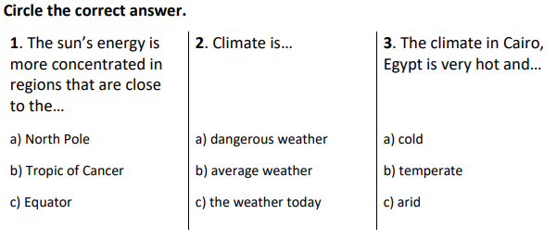

2. What does the Earth complete every 365 days?

3. What are the two Hemispheres of the Earth called?

Here are the monthly precipitation figures for Seville.

4. Which month is the wettest?

5. Which month is the driest?



