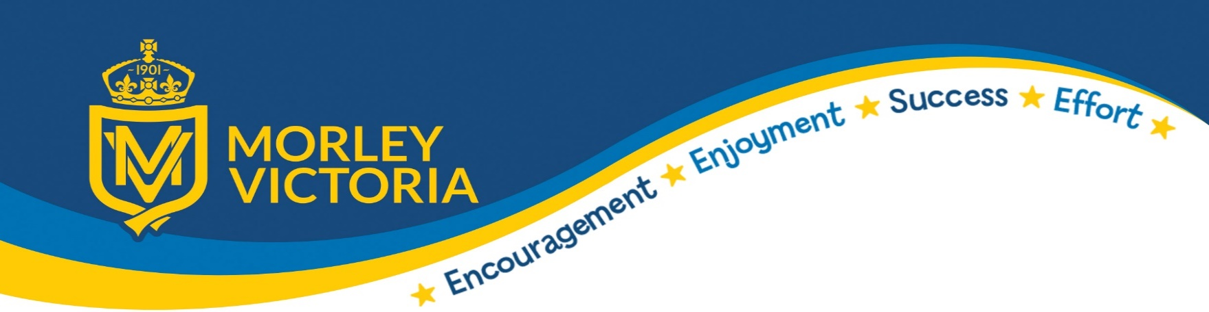
Intent, Impact and Implementation

Subject: PSHE
Intent  (What is the aim and purpose of your subject at MV?) | - This is a preventative curriculum.  - For children to gain the knowledge and skills required to stay healthy, happy and safe, and thrive in their futures.  - To develop pupils’ confidence, resilience, and self-esteem, and their ability to identify and manage risk, make informed choices and understand what influences their decisions.  - To support children developing the essential skills for future employability and achieving economic wellbeing.  - Support children in developing the capacity to be active and effective global citizens now and in their future.  - To provide a safe and happy learning environment where children can express themselves freely.  - For pupils to be encouraged to talk openly about their mental health and access support as and when required.  - Through the Cultural Cohesion Quality Mark, we will enable our pupils to develop their core values, to develop empathy and to recognise and respect cultural differences. These skills and values will help our pupils to connect with those around them.  - The CCQM will ensure that children from all backgrounds will feel valued and represented in an equal way.
Implementation  (How do we teach your subject at MV?) | - We follow the 1 Decision scheme of work - a clear, comprehensive and progressive curriculum working in line with the National Curriculum which includes opportunities to links to protected characteristics, character education, British values and SMSC. This us supplemented by other resources too.  - Typically, PSHE topics will be taught as weekly discrete sessions over a period of a half term, however this may be in blocks where appropriate so that we can best meet the children’s needs.  - Whole school, Key Stage and class assemblies always make a link to PSHE, protected characteristics, character education, British Values, Rights and SMSC – these are planned out each year.  - Phone numbers for services are now in planners ensuring children have access to support when at home. Children also can refer to their Helping Hands for support.  - We have a Tell Us button on our website so that children can make contact with us outside school time and in the holidays.  - All lesson now begin with sharing of Ground Rules for PSHE – these rules are consistent in all year groups  - CCQM will be embedded in PSHE lessons, to ensure that children understand the ethos behind it. Pupil’s will be taught about what culture means and to share and discuss their own culture. They will be taught about diversity and this will be promoted further through PSHE lessons. School will celebrate various weeks such as Diversity week and Black History Month.
Impact  (What difference does it make to the children/staff?) | - Children recognise the importance of personal attributes in gaining employment and financial stability.  - Children have high aspirations for their current next steps futures.  - Children can identify the features of a healthy relationship.  - Books and pupil voice demonstrate the progression of knowledge, skills and understanding.  - All children can recite their Helping Hands.  - Children are demonstrating an understanding of what good secrets are and when they should seek support.  - Children have a voice and their ideas shape the future of MV.  - Children contribute positively to our local community.  - Children have a healthy outlook towards school – attendance and behaviour are both good.  - CCQM will allow our children to understand and experience the rich and diverse communities of the world and encourage everyone to work in a harmonious way.

