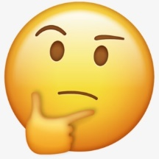

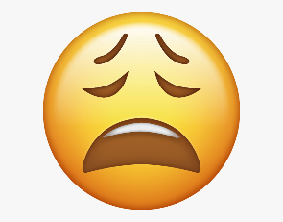

PSHE Vocabulary Year 1
How well do I know the word?
I’ve never heard the word before
I’ve heard this word but I don’t know what it means
I know what this word means but I can’t explain it.
I know what this word means and I can use it in a sentence.
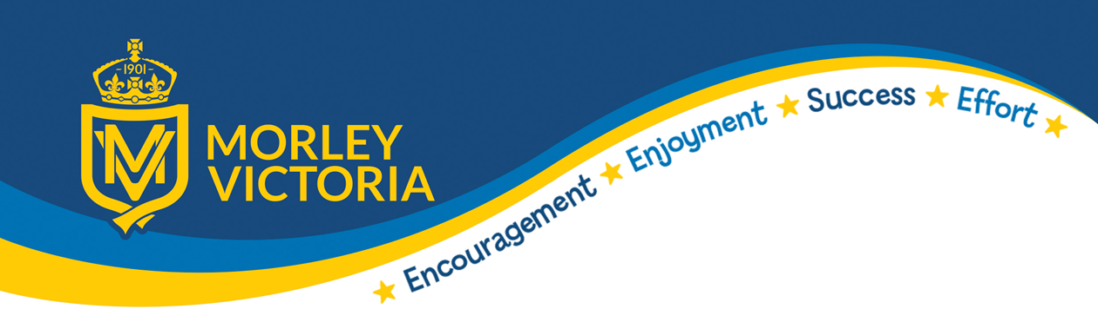

KEY VOCABULARY
Earn Job Harmful Safe Special Memories
Unique Responsibilities Danger Secrets Feelings
Kindness Respect Honesty Permission Love Generosity

