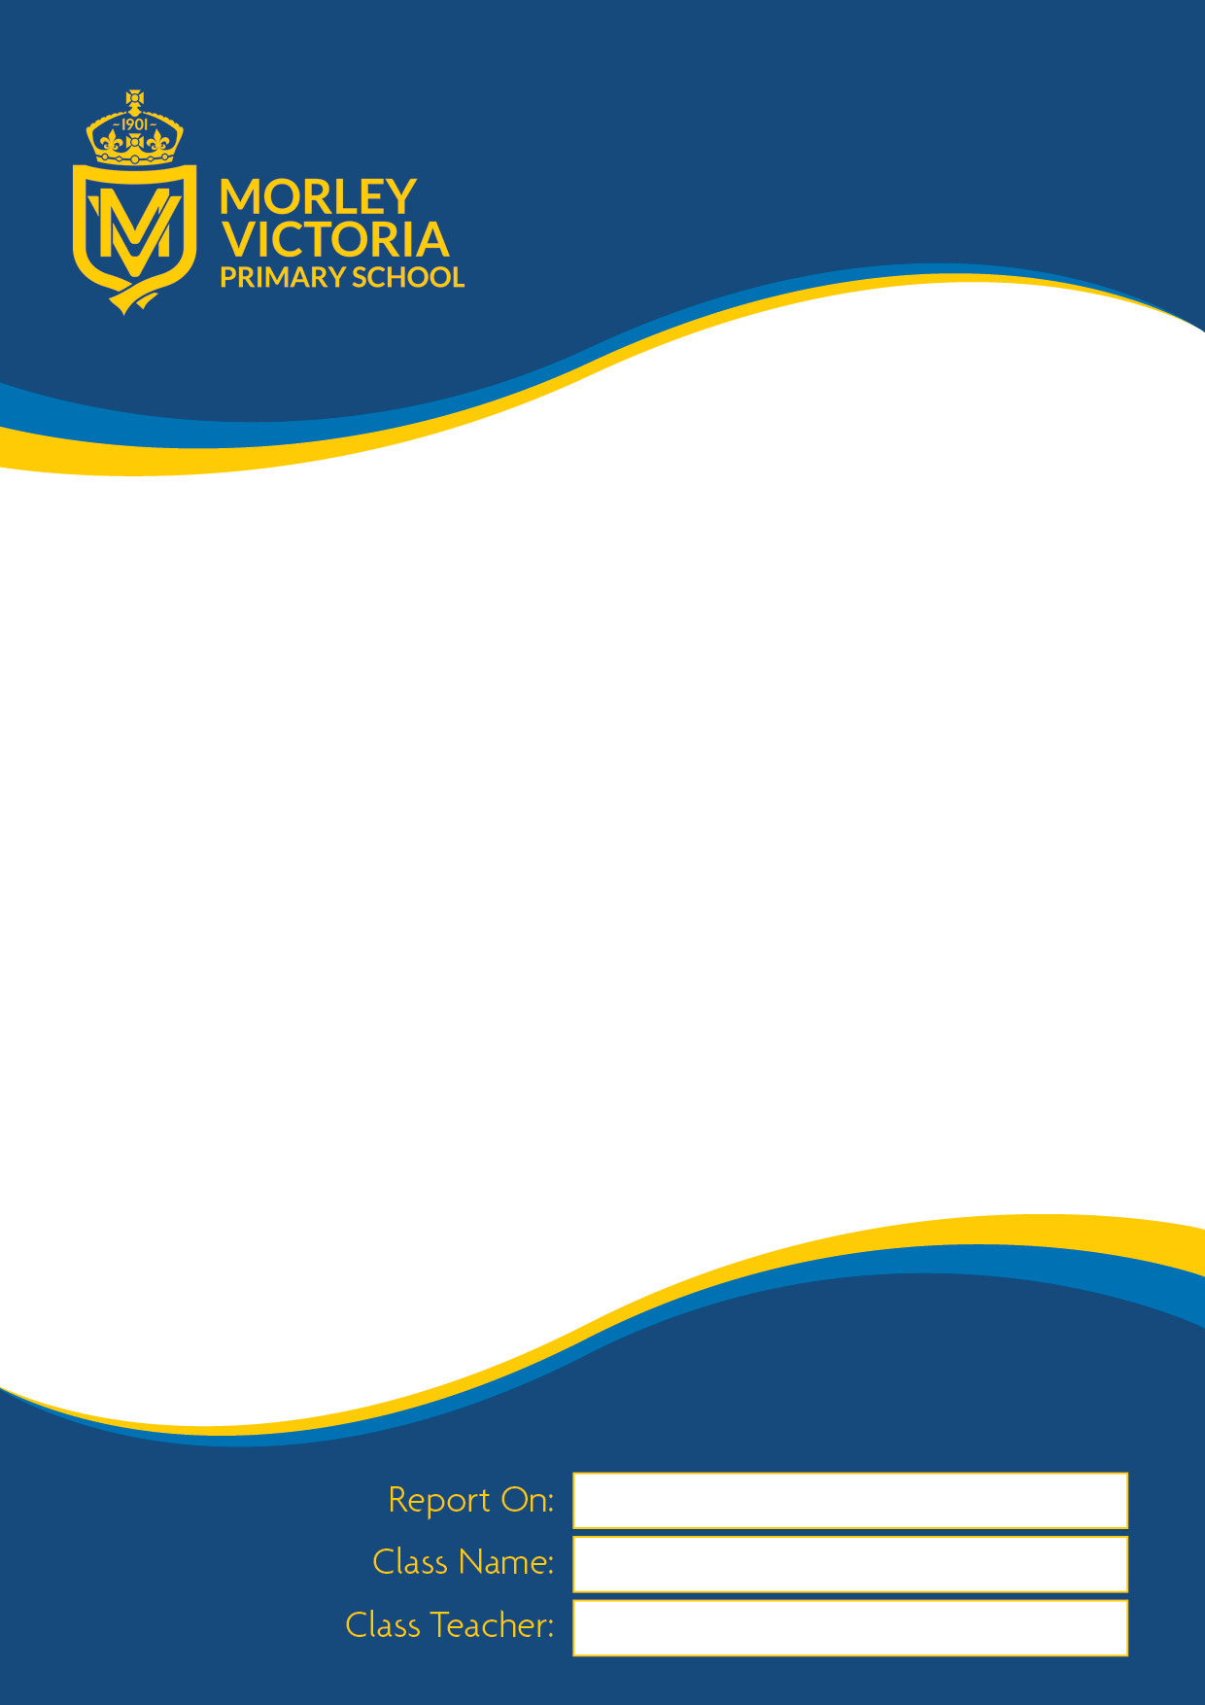
School Report

School Report
report

Academic Year 2024 -2025



School Report

September 2018 – July 2019
September 2015 – July 2016

ABC

RVM

Miss Mapplebeck

At the end of the Reception year, the children are assessed against the Early Learning Goals for each area of the curriculum. The children are assessed as either: emerging (have not yet met the expected level) or expected (have met the expected level). Part of this assessment is also whether the children have achieved GLD (a good level of development), which is achieved by being at the expected level in all prime areas of learning, as well as literacy and mathematics. An effort grade of excellent (1), good (2), sometimes works well (3) and needs to improve (4) is also included. If you have any questions or queries regarding anything in this report, please make an appointment with your child’s class teacher.

Characteristics of Effective Teaching and Learning, Prime Areas of Learning:
Personal, Social and Emotional Development, Communication and Language, Physical Development, Specific Areas of Learning: Understanding the World and Expressive Arts and Design
Literacy | Mathematics
Class Teacher’s Signature  V.Mapplebeck | Headteacher’s signature  Mrs Wood

Characteristics of Effective Teaching and Learning | Area of Learning and Development | Aspect | Emerging | Expected | Effort
Playing and Exploring  Children investigate and experience things and ‘have a go’ | Prime Areas
 | Communication and Language | Listening, attention and understanding
 | Communication and Language | Speaking
 | Personal Social and Emotional Development | Self-regulation
 | Personal Social and Emotional Development | Managing self
 | Personal Social and Emotional Development | Building relationships
Active Learning  Children concentrate and keep on trying if they encounter difficulties and enjoy achievements | Physical Development | Gross motor skills
 | Physical Development | Fine motor skills
 | Specific Areas
 | Literacy | Comprehension
 | Literacy | Word reading
 | Literacy | Writing
Creating and Thinking Critically  Children have and develop their own ideas, make links between ideas and develop strategies for doing things | Mathematics | Number
 | Mathematics | Numerical patterns
 | Understanding the World | Past and present
 | Understanding the World | People, cultures and communities
 | Understanding the World | The natural world
 | Expressive Arts and Design | Creating with materials
 | Expressive Arts and Design | Being imaginative and expressive
GLD (Good Level of Development) achieved |  | Yes |  | No

