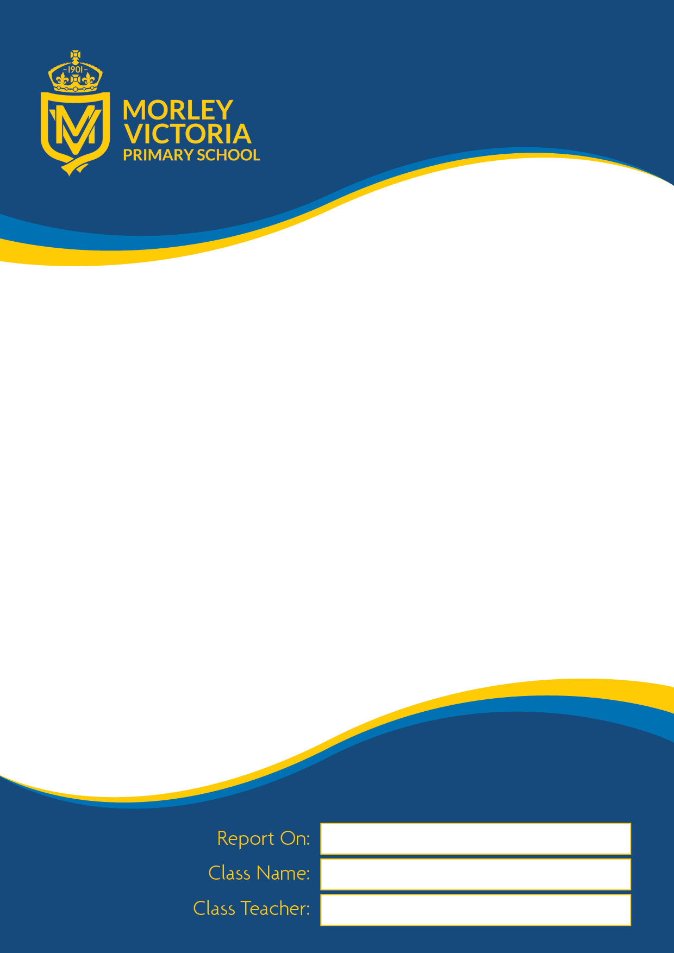
School Report

School Report
report

Academic Year 2024 -2025



School Report

September 2018 – July 2019
September 2015 – July 2016

ABC

Nursery

Mrs Wilks and Miss Cannell

In Nursery we follow the Early Years Foundation Stage (EYFS) curriculum. This report details how your child is developing in Nursery. The children are assessed as either: emerging (have not yet met the expected level) or expected (have met the expected level). This report will include information on where your child’s learning should go next to ensure progression. Included is a commentary about how your child approaches learning in school, including their Characteristics of Effective Teaching and Learning, as well as a commentary about how your child is progressing in the Prime and Specific Areas of the curriculum.

ABC
If you have any questions or queries regarding anything in this report, please make an appointment to discuss these with your child’s class teacher.

Characteristics of Effective Teaching and Learning, Prime Areas of Learning:
Personal, Social and Emotional Development, Communication and Language, Physical Development, Specific Areas of Learning: Understanding the World and Expressive Arts and Design.
Literacy | Mathematics
Class Teachers’ Signature  Mrs Wilks and Miss Cannell | Headteacher’s signature  Mrs Wood

Characteristics of Effective Teaching and Learning | Area of Learning and Development | Aspect | Emerging | Expected
Playing and Exploring  Children investigate and experience things and ‘have a go’ | Prime Areas
 | Communication and Language | -Listening, attention and understanding  -Speaking
 | Personal Social and Emotional Development | -Self-regulation  -Managing self  -Building relationships
Active Learning  Children concentrate and keep on trying if they encounter difficulties and enjoy achievements | Physical Development | -Gross motor skills  -Fine motor skills
 | Specific Areas
 | Literacy | -Comprehension  -Word reading  -Writing
Creating and Thinking Critically  Children have and develop their own ideas, make links between ideas and develop strategies for doing things | Mathematics | -Number  -Numerical patterns
 | Understanding the World | -Past and present  -People, cultures -and communities  -The natural world
 | Expressive Arts and Design | -Creating with materials  -Being imaginative and expressive

