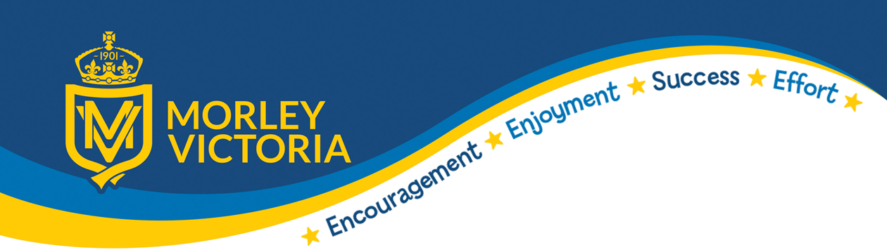

SMSC in Geography

Spiritual Development
There are many ways in which geography can contribute towards spiritual development, the study of real people in real places, and of our relationship with the environment, is at the heart of the geography curriculum. As such, there are many occasions when we can give pupils the opportunity to reflect on their own values and beliefs, and those of others. For example, we can give pupils opportunities to think about the feelings of a child living in a refugee camp, or the victims of a natural disaster. Children can reflect on the beauty of a landscape and explore their own feelings about the people, places and environments they are learning about.

Moral Development
Most geographical issues have a moral dimension. Environmental relationships, in particular, provide a wealth of opportunities for distinguishing a moral dimension; for example, should the rain forest be exploited? Should open cast mining be allowed in an area of outstanding natural beauty? Discussion, role-play and decision-making exercises enable pupils to explore such issues. In doing so they will learn about the views held by society, and by various groups within society, and will develop their own attitudes and values in relation to these.

Social Development
Activities in the geography classroom – paired work, group work, role-play, geographical games, all foster good social behaviour and self-discipline. However, through fieldwork geography makes a distinctive contribution to social development. Outside of the classroom, a successful trip relies on each member of the class making his or her full contribution. Geography also has a key role in developing an understanding of citizenship. For example, decision making exercises introduce pupils to the planning process in a town or city; learning about international trade fosters a sense of the interdependence of people and places; and through geography pupils develop a knowledge and understanding of the concept of sustainable development.

Cultural Development
Through its study of real people in real places, geography makes a major contribution to cultural development. Pupils learn about the characteristics of their local area, and why it is like that, and contrast where they live with more distant localities, in this country and abroad. A sense of place requires a knowledge and understanding of the cultural traditions of the people who live there. For example, for younger pupils this could be knowing about different styles of dress while older pupils might explore different attitudes towards the environment. Geography is a natural vehicle for exploring our own multicultural society. The history of settlement can be explored through the distribution of place names while the spatial distribution of ethnic groups can be analysed, and its causes and consequences considered.

