
4
Morley Victoria Primary School
Relationship and Behaviour Policy
Rationale
At Morley Victoria Primary School it is our primary aim that every member of our school community feels valued and respected, and that each and every person is treated fairly and well. We are a caring and inclusive community whose values are built on mutual trust and respect.
The school’s behaviour policy is designed to support the way in which everyone can work together in a supportive way and to champion an environment where everyone is happy, and feels safe and secure. We promote good relationships, good behaviour and good role models and we have an ethos of kindness and co-operation.
Our policy draws on research in neuroscience, psychology and adverse childhood experiences and is based on the book by Paul Dix – ‘When adults change, everything changes’. It is underpinned by an expectation that by modelling, celebrating and recognising agreed positive behaviours, our children are ready to learn effectively.
Many children, at some point, will need help to manage and articulate their emotions. Children who find it most difficult to conform to ‘good behaviour’ need to be treated with respect and made to feel valued. Effective teaching and learning is dependent upon positive relationships between staff and pupils, and between pupils themselves. We will work together to identify the reasons for a child’s behaviour and put strategies in place to support the child to make positive steps.
At Morley Victoria we have based our policy on an overwhelmingly positive approach towards managing behaviour. The policy is based on a clear set of rules, incentives and rewards; and when required children will be worked with to teach them how to behave in a positive manner - these will all be appropriate to the age of the children. This policy is supported by our work on Personal Development with our Inclusion Team, our PSHE / PSED Curriculum including MindMate, Zones of Regulation, Investors in Pupils, CCQM, Growth Mindsets, and Healthy Schools – having good behaviour is a key area in gaining and maintaining high standards in each of these initiatives.
Aims
Our school aims to:
- Promote a positive climate to life and learning within school by being Ready, Respectful and Safe (RRS)
- Provide a safe environment where learning is enjoyable
- Offer an exciting, bespoke and challenging curriculum for all children
- Promote good relationships with others in school and the community
- Ensure the children and families understand the word behaviour
- Help each individual to discover and develop new skills.
- Provide challenge and support to achieve high standards
- Encourage and support children to become well rounded, self- disciplined, respectful, moral and caring.
- Ensure that children move on to the next stage of their education confidently, knowing what is expected of them and being able to rationally deal with new situations.
At Morley Victoria our emphasis is on positive behaviour and reinforcing this, rather than focusing on failures. Rewards are aimed to motivate and help children to make the right choices. The success of our policy will not be tested by the absence of problems but the way in which we deal with them. Our policy will be applied fairly, consistently and in line with what we feel is best for the child/children.
Promoting Positive Behaviour at Morley Victoria
We believe that behaviours that are positively rewarded are more likely to be repeated and so we feel it is important that the children enjoy a wide range of positive consequences across each and every day at school.

Rewarding Positive Behaviour

We praise and reward children for positive behaviour in a variety of ways:

Staff comment on children being ready, respectful and safe
- Staff comment on those children who go over and above
- Staff give out stickers and stamps
- Hot chocolate Friday
- Children go to see other staff members when they have done something well
- Children receive certificates in the school assembly for positive behaviours; this fits in with the areas of our creative curriculum
- We give rewards to children either for consistent good work or behaviour, or to acknowledge outstanding effort or acts of kindness in school
- All classes have an opportunity to take part in a celebration assembly where they are able to show examples of their best work and what the children have been successful on outside of school
- Children can earn individual Dojo points for behaviour and learning in school
- Children in Year 3 and 4 can earn team points
- Parents / carers are invited in half termly to celebrate ‘Teacher’s Pupil’ and ‘Pupils’ Pupil’ in special assemblies
- Praise postcards are sent home each half term
- Attendance postcards and texts are sent out half termly/termly for 100% attendance and improve attendance and punctuality
- Children given roles and responsibilities in school

The school acknowledges all the efforts and achievements of children, both in and out of school. Children are actively encouraged to share their achievements out of school during class times in news time and during celebration assemblies.

Our work on having better behaviour links to our work on Investors in Pupils, at the beginning of the year, the class teacher discusses the school expectations with their class. In addition to the school expectations, each class also has its own mission statement, which is agreed by the children and displayed on the door of the classroom – this links to our whole school rules (RRS).
Undesirable Behaviour

From time to time pupils may display unacceptable behaviours. These will be consistently challenged by all staff so that all pupils are safe and happy at school and learning can take place and is not disrupted. All adults will use good behaviour management techniques which allows children to correct their behaviours. Children are made aware of the behaviour system at the beginning of the school year and are reminded of the expectations regularly. All adults in school follow through all instances of socially unacceptable behaviour in the following ways:

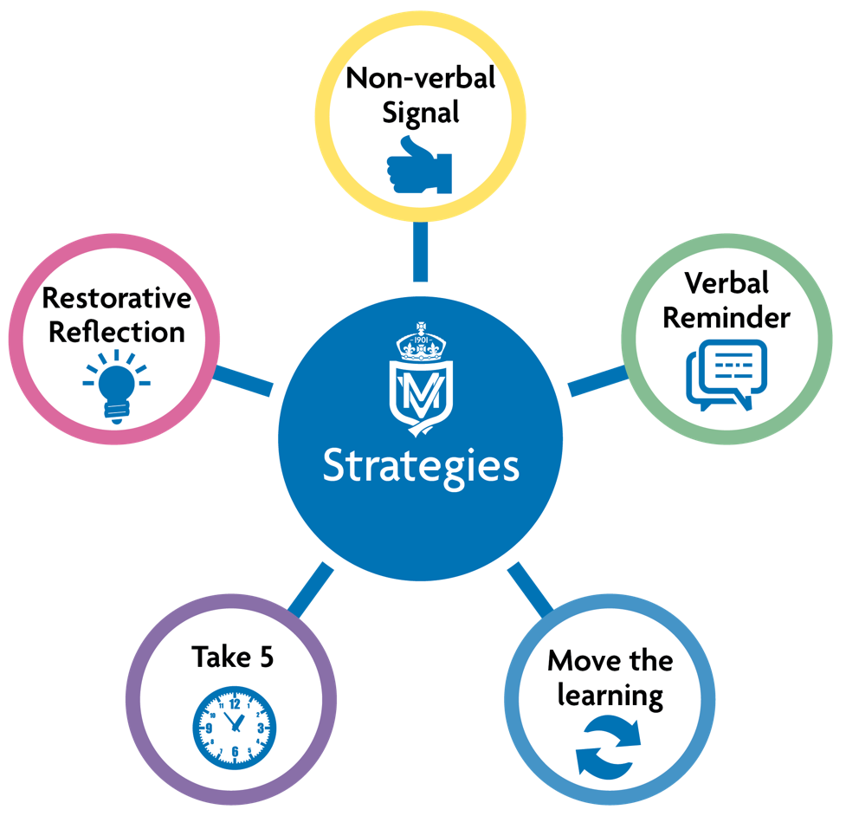

Description
Non-verbal Signal
Adult signals the appropriate behaviour and allows the child to make the changes, eg, hand gesture, face gesture, eye contact, role model signalling. This is reinforced and followed up with a positive gesture, eg, smile, thumbs up.
Verbal Reminder
Adults will state the inappropriate behaviour and give a verbal reminder, eg, Name (pause) you’re disrupting the learning. I need you to …… thank you. This can happen close to the child or from the front of the room depending on the child.
Be mindful of tone and volume of voice. This is followed up with positive comments/gestures to demonstrate you have noticed the positive change.
Move the learning
This may be to another place in the classroom or an agreed area where
learning can happen more effectively.
Take 5
If the behaviour continues a child may be asked to take time. This may happen in or outside of the learning environment (this will be dependent on the child).
Restorative Reflection
Once regulated, a restorative conversation should take place between the adult and the child (using the classroom toolkit). It is important the child as enough time
to reset.

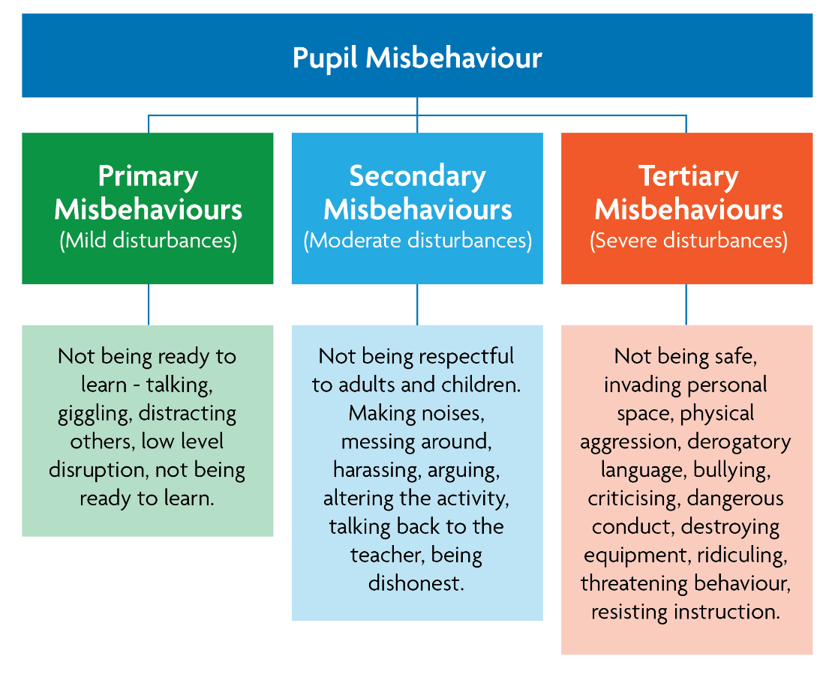

Consequences

All behaviour- both positive and negative have consequences. All negative behaviour that is in breach of the school rules results in negative consequences for the pupil who has made the wrong choice. Staff are consistent when explaining and enforcing the school rules. Expectations are high and will challenge unacceptable behaviour. When pupils misbehave this will be dealt with promptly, predictably and with confidence to maintain a calm and safe learning environment for all. The main consequence is a breakdown in a relationship that then needs work to restore it. Other natural consequences may be to tidy up a mess they have made, fix something that has been broken or miss the next task because the previous one has not been done. We employ each consequence appropriately (reasonably and proportionately) to each individual situation and each one is designed to be restorative in its approach and results in a reduction of the inappropriate behaviour.
Examples of consequences could be (please note these are individual to the child and what we know will work of each child):

- Apologise to the adult/child they have been rude to.
- Write an apology card to a member of staff for being rude in their session.
- We may ask them to redo a task if they have not done something well enough.
- Spend their break/lunchtime with an adult.
- Play away from a child they may be having issues with.
- Write an apology letter/card to a child they have upset.
- Complete work set in their own time – break/lunchtime.
- Help to mend something after damaging it.
- Tidy up an area if they have created the mess.
- Have their privileges/roles in school removed.
- Meet parents to discuss the issues.
- Have a behaviour contract in place

All the above consequences are for an agreed period of time and we will monitor behaviour carefully and make any adjustments when necessary.
Incidents will be recorded on CPOMS under the correct behaviour tag. Please note that not every incident of behaviour will be recorded as this would be an impossible task– just the ones we professionally feel need recording.
Behaviour at Basement Buddies, playtimes and lunchtimes will also be monitored and dealt with in the same way – all adults looking after children in these areas and environments will have the appropriate training.

Playtimes and Lunchtimes

Our playgrounds are places of fun, joy and crucial learning. Sessions are a well thought out and considered part of the school day. The team are trained in the core fundamentals of play as an extended learning time to develop personal and physical skills.
Staff ensure that children enjoy a safe and happy time outdoors and identify concerns with behaviour quickly to catch moments as a teaching platform. On occasions, where children are displaying behaviours which are not safe, being unkind to others or not following our promise, staff act quickly. Where serious incidents of serious misconduct occur, leaders are alerted and a plan is placed around the child. The following may be put into place to support:
- Withdrawn from play and lunch for a period of time
- Separation of certain individuals
- Withdrawn from play/lunch for a period of time while restorative work takes place. The child then earns back trust to access the full range of activities
- A risk assessment placed around the child with certain provision such as a key worker, an early end time from the yard or specific areas to play
The adult dealing with the event will inform the teacher who will gauge whether communication with the parent/carer is necessary. All incidents must be logged on CPOMS so that patterns in behaviour can be identified by senior leaders.
Pupils whose behaviour at lunchtime is persistently disruptive may also be suspended from the school premises for the duration of the lunchtime period.
A positive behaviour approach emphasises that most interactions are positive ones. Staff, at all times, focus on positive reinforcement and ensuring that pupils feel like valued members of our school community. In the event of persistent disruptive behaviours occurring, staff will discuss with parents/carers and Senior Leaders in school to seek advice and take a proactive approach to reducing incidents as quickly as possible, before habits become established. Restorative practice is key in aiding children to understand the impact of their actions and learn how to do things differently.
Communication and family partnerships
Effective communication and positive family partnerships are crucial in maintaining high standards of positive behaviour and consistency. If a child has behaviour which is causing a concern in school steps will be taken to inform parents / carers. The class teacher will have the initial responsibility for this, alongside the Inclusion Team. Teachers will be responsible for reporting any early warning signs for behaviour and safety to a member of the Inclusion Team and on CPOMS (our record keeping system) so that strategies can be put in place and more formal steps can be taken.
The behaviour policy is shared with parents / carers. The Inclusion Team will work together to support and encourage parents / carers to share the same aims of the school in promoting good behaviour. They will signpost families to additional support where this is needed.
The Headteacher will share positive stories about best and improving behaviours. They will work in an open and honest way with families in order to achieve the aims of this policy.
The positive behaviour policy operates in conjunction with the following policies:
  - Anti-Bullying
  - All policies that relate to Online Safety
  - Child Protection and Safeguarding and Safer Working Practice
  - KCSiE guidance
  - Care and Control and Positive handing
  - Health and Safety
  - Teaching and Learning
  - SEND and Inclusion
  - Exclusion procedures
The following roles and responsibilities will be implemented in support of the positive behaviour policy:
Children are actively encouraged to:
- Follow the whole school rules if being Ready, Respectful and Safe
- Foster social relationships in the school community of mutual respect
- Be responsible for own actions and their impact on others
- Respect other people, their views and feelings
- Empathise with the feelings of others
- Be fair
- Be willing to be reflective and to change behaviours
- Follow the school rules
- Learn to work cooperatively with others

At Morley Victoria we will use a restorative approach to deal with negative behaviour which will put repairing harm done to relationships and people at the centre of the focus. The children should be taken through a given situation to ensure that they understand the harm that has been caused to all parties.

Staff will always:
- Use the RRS rules in everyday language with the children
- Provide a well-balanced and creative curriculum that will engage the children
- Support children when dealing with their emotions and feelings and will teach children how to do this through the PSHE / PSED curriculum
- Plan engaging and well differentiated lessons to challenge and meet the needs of all children
- Make sure children are listened to and feel valued
- Be a positive role model and teach pupils what good behaviour looks like, reminding them of the school’s behaviour policy
- Offer the children choices and the chance to make the right decision
- Support children with the language and vocabulary they need in order to socialise and develop interpersonal skills
- Reward and praise positive behaviour
- Inform parents/carers about the welfare and behaviour of their children
- Work in partnership with the Inclusion Team to ensure all procedures for individuals are followed, behaviour dealt with, needs met and paperwork completed
- Work in a restorative way to promote positive behaviours
- Promote a culture that sexual violence and sexual harassment is unacceptable and will never be tolerated
- Be aware of the issue of child on child abuse and will ensure that this is not tolerated
- Promote cultural diversity and cohesion.

The Inclusion Team will do everything they can by:
- Supporting the staff with help and advice when children need help with their behaviour in the classroom
- Working with the children, using targeted support, on a 1:1 or in a small group to support their behaviour needs and work on restorative practice
- Liaising with and communicate with families alongside the class teacher
- Making referrals to outside agencies, eg, Cluster and the AIP where appropriate
- Meeting every other week to discuss the work they are carrying out with the children to share ideas, update the SLT and ask for additional advice where required.

The Headteacher’s responsibility to the children, families and staff will be to:
- Implement the positive behaviour policy, reinforcing the need for consistency throughout the school. This is in line with the School Standards and Framework Act 1998 and section 89 of the Education and Inspections Act 2006
- Be highly visible to staff, pupils, parents/carers and the school community
- Report to governors regarding the effectiveness of the policy
- Meet with parents/carers of challenging children
- Support staff when dealing with challenging behaviour and the law
- Ensure the health and safety and welfare of all children
- Praise and encourage positive behaviour with rewards and dedicated assemblies
- Ensure that new staff receive an induction whereby this policy is shared to set standards and support new staff in its implementation
- Chair a meeting of the Inclusion Team every other week to discuss how to support children who are struggling with their behaviour and signpost to outside agencies if required
- Take responsibility for giving fixed term exclusions for serious acts of misbehaviour and may have to take the decision to permanently exclude a child in the event of serious acts. The Leeds City Council procedures will be followed at all times
- Keep a record of any pupil exclusions
- Support staff in how to deal with incidents that occur online.

Parents / carers are asked to support the school by:

- Adhering to the Home School Agreement that was signed on entry to Morley Victoria and be supportive of the school with the Home School Triangle
- Reading the school prospectus which explains the school expectations and support the aims of this policy
- Working collaboratively with the school so that the children receive consistent messages about how to behave at home and at school
- Supporting their child’s learning and co-operate with the school with matters that arise
- Approaching the school in the correct manner if there are concerns around behaviour and work collaboratively and in a supportive way to benefit the child
- Supporting the school in their actions should sanctions have to be implemented and reinforce the key messages at home
- If a family have concerns about any actions by the school the class teacher should be contacted in the first instance. If this is unable to be resolved then they should contact a member of the Inclusion Team followed by one of the Assistant Headteachers. The Headteacher will become involved once all other avenues have been exhausted
- If families wish to make a formal complaint they should view the Complaints Policy and Procedure which are on the school website.

The Governing Body will ensure that:

- They are responsible for setting down the general guidelines on standards of behaviour and discipline and reviewing their effectiveness
- They delegate the day-to-day management of the policy to the Headteacher
- Support is given with the implementation of the policy
- Advice will be provided to the Headteacher regarding disciplinary issues and exclusions (if requested), which will be taken into account when making decisions
- A ‘Discipline Committee’ is formed in the event that a family wish to appeal against the school’s decision to exclude a pupil
- They monitor the rate of exclusions
- This policy is administered fairly and consistently by the school.

Key Points to note:

- Teachers have a statutory authority to discipline pupils whose behaviour is unacceptable, who break the school rules or who fail to follow a reasonable instruction (section 91 of the Education and Inspections Act 2006)

- The power to discipline also applies to all staff (unless the Headteacher says otherwise) with responsibility for pupils.

- Any incidents of bullying (including child on child abuse), discrimination, aggression and derogatory language is dealt with quickly and effectively.

- Teachers can discipline pupils at any time the pupil is in school or elsewhere under the charge of the teacher, including on school visits.

- Teachers can also discipline pupils for misbehaviour outside of school.

- Teachers can confiscate pupils’ property.

- Teachers have a power to impose detention out of school hours.

- Headteachers and Governing Bodies must ensure they have a strong behaviour policy to support staff in managing behaviour, including the use of rewards and sanctions.

- Governing Bodies have a duty under section 175 of the Education Act 2002 requiring them to make arrangements to ensure that their functions are carried out with a view to safeguarding and promoting the welfare of children.

(Taken from the DFE guidance – behaviour and discipline)

Bullying

For the sake of our whole school community, Morley Victoria does not tolerate bullying of any kind. If we discover that an act of bullying or intimidation has taken place, we act immediately to stop any further occurrences of such behaviour. We do everything in our power to ensure that all children attend school free from fear.

Bullying is an agenda item at team meetings and an electronic record is held on CPOMS of any incidents. Each year we have assemblies and class activities around anti-bullying and each child completes a questionnaire about being happy and safe both in and out of school. Any issues that are raised are then followed up personally by the class teacher or Headteacher.

The Anti-Bullying Policy should be referred to when an incident has been classed as bullying. The ‘victim’ and the ‘perpetrator’ will be supported accordingly and appropriately by the Inclusion Team with the support of families to ensure that school life can be improved for both parties. The Anti-Bullying Ambassadors have also written their own (child friendly) Anti-Bullying Policy which is shared across school.

Serious Incidents that require restraint

All members of staff are aware of the regulations regarding the use of force by teachers, as set out in DfEE Circular 10/98, relating to section 550A of the Education Act 1996: The Use of Force to Control or Restrain Pupils. Teachers in our school do not hit, push or slap children. Staff only intervene physically to restrain children or to prevent injury to a child, or if a child is in danger of hurting him/herself. The actions that we take are in line with government guidelines on the restraint of children and follow the Team Teach approach. Staff will be offered Team Teach training as appropriate. All incidents will be recorded and violent incidents reported to the local authority Health and Safety Team.

Attachment

This behaviour policy works for the vast majority of our children. There are some children however who do suffer from attachment issues, so therefore need to be thought about differently.

All of our staff have had ‘Attachment’ training and we are developing strategies to deal with these children both in and out of classroom environments because we recognise one behaviour policy does not work for all children, especially those who have specific difficulties.

Staff may have to make reasonable adjustments in these circumstances. The plans and support strategies we have for these children will be discussed with them, as part of the Inclusion meeting and with parents / carers on a regular basis to ensure progress is made emotionally, socially and academically.

Children with SEND
We know our children very well because we take the time to understand their individual needs. It is important that a child with SEND understands, at their own level, what constitutes appropriate behaviour in school and at home; and time is taken to talk with children and families about how we can help and support the children to know what is acceptable and what is not. This is also very dependent upon the condition that they have and each case is treated individually and respectfully.
We have a duty of care to our older children to ensure that they understand the rules and systems that will be in place at high school and that systems will be different and much more strict than those at Morley Victoria. We will help and support in an appropriate way to make the transition process as good as it can possibly be.
Reasonable Adjustments
A reasonable adjustment never means that we lower our expectations. It means that for some children additional support is required to ensure that they meet the high expectations that we have of our children.
Morley Victoria Primary School may, in line with the requirements of the Equality Act 2010, make reasonable adjustments for children with SEND in relation to this policy where it is deemed appropriate.
In order to ensure out duties are met under the Act we will:
- Consider the SEND code of Practice
- Monitor behaviour logs on CPOMS for those children with SEND
- Call meetings where a need has been raised and a child is having difficulties meeting academic and social and emotional expectations

Fixed Term and Permanent Exclusions
If, despite all best efforts, restorative practice is unsuccessful and a child’s behaviour remains extreme, it may be necessary to exclude a child from school for a period of time. Only the Headteacher has the authority to exclude a pupil from school. In the event of the Headteacher being unable to authorise this sanction, approval must come from the Chair of Governors.
The Headteacher may exclude a pupil for one or more fixed periods, for up to 45 days in one school year. The Headteacher may also exclude a pupil permanently. It is also possible for the Headteacher to convert a fixed term exclusion to a permanent exclusion if the circumstances warrant this.
If the Headteacher excludes a pupil, they will inform the parents / carers immediately, giving reasons for the exclusion. At the same time, the Headteacher will make it clear to the family that they can, should they wish, appeal against the decision to the Governing Body and will share how to do this.
The Headteacher will inform Leeds City Council and the Governing Body of the exclusion.
The Governing Body itself cannot exclude a pupil or extend the exclusion period given by the Headteacher.
The Governing Body can call upon a ‘Discipline Committee’, made up of between three and five members, to consider and exclusion appeals on behalf of the Governing Body. When this committee meets they must consider the circumstances in which the pupil was excluded, consider any representations by a parent / carer and the Council and should consider whether the pupil should be reinstated. If the Governors’ Discipline Committee decides that a pupil should be reinstated, the Headteacher must comply with this ruling.
Partial Timetable may be needed that it fits the needs of the child at that time. We will ensure the right level of support is given to the child at all times and maintain a close working relationship with the parents/carers. We will also work with outside agencies to ensure what together we are providing the right package to best support the child.

Confiscation of inappropriate items
What the law allows:
There are 2 sets of legal provision which allows staff to confiscate items from pupils:
1. The general power to discipline enables a member of staff to confiscate, retain or dispose of a pupil’s property as a punishment and protects them from liability for damage to, or loss of, any confiscated items. The legislation does not describe what must be done with the confiscated item.
2. Power to search without consent for ‘prohibited items’ including:
- Knives and weapons
- Alcohol
- Tobacco
- Stolen items
- Fireworks
- Where there is suspected ‘Nude/semi nude’ images
- Where there is suspected pornographic images
- Illegal drugs
- Any article that has been or is likely to be used to commit an offence, cause injury or damage to property.
- Any item banned by the school rules which has been identified in the rules as an item which may be searched for.
3. Weapons, knives, phones with suspected nude or semi nude images or extreme or child pornography must always be handed over to the police.
Staff must remember that, in accordance with KCSiE, they are not allowed to view images of a child or young person, therefore if it is suspected that inappropriate images are present, the device must be given to the Police.
Pupils conduct outside the school gates
What the law allows:
At Morley Victoria Primary School we have high expectations of the children’s behaviour and would expect the children to behave properly on their way to and from school, and when wearing our school uniform. We would also expect them to behave properly when they are engaged in extended school activities which take place beyond the normal school day – e.g. football matches. Section 85 (5) of the Education and Inspectors Act 2006 gives Headteachers a specific statutory power to regulate pupils’ behaviour in these circumstances ‘to such an extent as reasonable’.
Subject to the positive behaviour policy, teachers may discipline pupils for:
- Taking part in any school organised or school related activity or
- Traveling to or from school or
- Wearing school uniform or
- In some other way identifiable as a pupil at the school.
Or misbehaviour at any time whether or not the conditions above apply that:
- Could have repercussions for the orderly running of the school or
- Poses a threat to another pupil or member of the public or
- Could adversely affect the reputation of the school.
In all cases of misbehaviour the teacher can only discipline the pupil on school premises or elsewhere when the pupil is under the lawful control of that staff member.
Attendance on school trips is deemed to be a privilege and therefore any child who cannot display appropriate behaviour will not be accepted onto the school trip. This may also be due to the health and safety of themselves and other children.

Use of reasonable force
The legal provision on school discipline also provides members of staff with the power to use reasonable force to prevent pupils from committing an offence, injuring themselves or others, or damaging property, and to maintain good order and discipline in the classrooms.
The Headteacher and authorised school staff may also use such force as is reasonable given the circumstances when conducting a search without consent for knives or weapons, alcohol, illegal drugs, stolen items, tobacco and cigarette papers, fireworks, pornographic images or articles that could have been used to commit an offence or cause harm. If a member of staff has to physically hold a child, the Positive Handling Policy will be adhered to.

Malicious Allegations
At Morley Victoria Primary School, allegations of abuse will be taken seriously and acted upon in a fair and consistent way in which both the child and the person who is the subject of the allegation will be supported.
All allegations (whether they are a low level concern or an upheld allegation) will be treated confidentially and every effort will be maintained to guard off any publicity while the allegation is investigated. Suspension of staff would not be an automatic response to an allegation. The school will refer to Keeping Children Safe in Education; the Safer Working Practice Guidance and the Child Protection Policy as required.

Monitoring
The Headteacher will monitor the effectiveness of this policy on a daily basis. They will also report to the Governing Body and if necessary will make recommendations for further improvement.
This policy will be reviewed on an annual basis. However, the Governors or the Headteacher may choose to review this policy earlier than this if the policy is not being effective, if new recommendations are made or if the Government introduces new regulations.

Steps that will be taken by school in the event of inappropriate behaviour – to be included in coloured chart:
- Children will firstly receive a look from their teacher if they are disrupting the lesson or not following class rules.

- If the behaviour persists children will receive a verbal warning from their teacher.

- If the disruption continues, the child will then be asked to move to a different part of the classroom to continue with their work.

- If the child does not complete the required amount of work due to their behaviour or are still failing to follow class rules, then they will miss out on one of their break times to reflect upon their behaviour and complete any work missed.

- If a child has got to an emotional point whereby they need support from another adult or change of environment, then a member of the Inclusion Team will come to get the child and take them to a quiet space to have restorative conversations. When the child is calm and ready to focus, they may return to the classroom at an appropriate time.

- Should the behaviour persist, the child will be removed from the lesson for the remainder of the morning or afternoon.

- If the wrong choices continue to be made over a period of time, the child may spend the following day ‘secluded’ from the class (this would be formally recorded on CPOMS). In this case, the class teacher will set work for the child but they will remain alone without their peers for the whole day. Supervision and restorative work will be done by the Inclusion Team.

- Should this need to happen on a regular basis, families will be informed and regular meetings will be set up

Enhanced Support Behaviour
- We will seek advice and support from the Morley Cluster if required as an additional support mechanism. Their services include: Educational Psychology, Art Therapy, Lego Therapy, Counselling and Family Support.
- Children can be placed on a positive behaviour plan with an agreed contract signed by the child and family
- Seclusion
- Early Help assessment
- If a child becomes a danger to themselves or others and behaviour deteriorates dramatically and all other measures and strategies have been exhausted extensively – a child may be excluded as a last resort. The school will NOT do this lightly and without thought.
- Severe cases will be discussed as an Inclusion Team and if the school feels that there is no other choice, they will contact the AIP (Area Inclusion Partnership) for advice and assessment which may result in a child benefitting from some time away from Morley Victoria in a specialist setting that can cater for their needs and appropriate therapy undertaken.
- All children are welcome back at Morley Victoria following a period of time away; supported and reintegrated on a specialist plan given by the alternative provision. Staff at Morley Victoria will be supportive of this plan and will do everything possible to reintegrate the child back into the classroom.
- The very last resort will mean that a child is permanently excluded from Morley Victoria and a new school will be found with support from the AIP. A full and proper transition will be implemented.

