

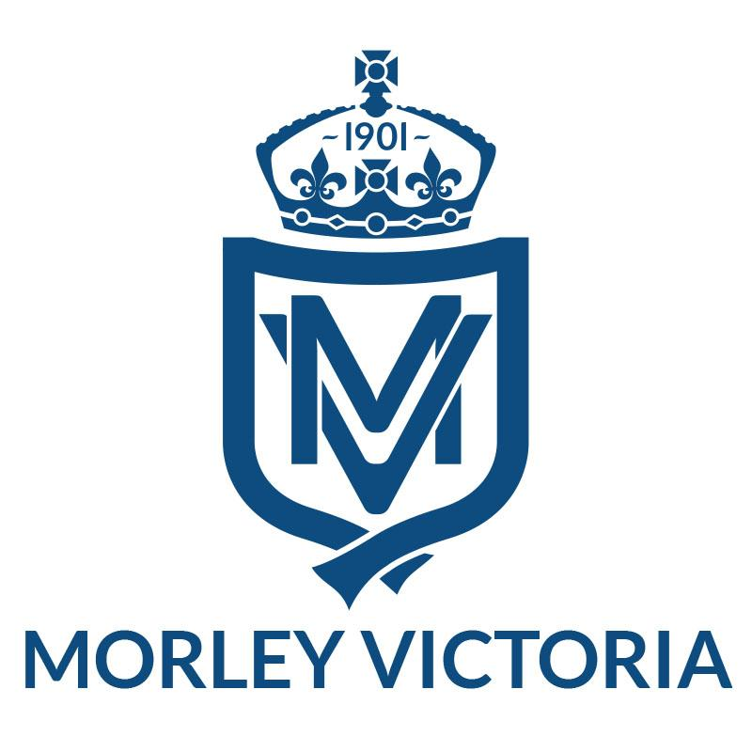

NUT ALLERGY AWARENESS POLICY

This policy sits alongside the Medicine Administration Policy, the School Food Policy and includes aspects of safeguarding which are everyone’s responsibility.

Purpose
The purpose of this policy is to:
- Raise awareness about allergies to our school community
- Ensure we are providing a safe learning environment for all
- Give assurance to those children/families with severe allergies that we take the management of these seriously.

Aim
We are not a nut-free school but we aim to be as nut-free as we possibly can be. It is impossible to provide an absolute guarantee that no nuts will be brought onto the premises but we will strive to minimise this risk as much as we can by raising awareness; sharing information and promoting this within the school community.

Management
We ask that all members of the school community manage the day to day application of this policy in the following ways:
- Parents / carers are requested NOT to send food to school that contains nuts. This includes all types of nuts: peanut butter, Nutella, cereal/chocolate bars containing nuts and any other food containing nuts. This includes any baked goods brought into school as part of any celebration or learning project by children.
- Staff will be alert to any obvious signs of nuts being brought in, but they will not inspect all food brought into school.
- Children that DO bring in food that does contain nuts or nut products will be asked to eat that food away from any child with a nut allergy and to wash their hands afterwards.
- Children will be asked NOT to share food.
- Children will be encouraged to wash hands before and after eating.
- Some staff are trained in understanding and dealing with Anaphylaxis (severe allergic reactions) and will use this training as the need arises. Staff who have children who use adrenaline auto-injector pens (EpiPen or equivalent) are also trained.
- The school dinner providers will ensure all food is nut-free as per their guidelines and prepared taking allergies into account as per Leeds City Council Catering guidance.
- Children who have any form of allergy to foods wear an allergy lanyard at lunchtime which contains their name and the allergy that they have. Their meals will be served separately under cover and stored with a sticker with their name on.
- Adrenaline auto-injector pens (EpiPen or equivalent) and quick response medicines are kept in the red medication bags on the back of classroom doors.
- The medical information for children who have a nut allergy will also be kept in the red medication bag on the back of classroom doors.
- All adults that will work with children with a nut allergy (lunch staff, supply teachers, PE coach etc) will be made aware of their allergies before coming into contact with the children.

Promotion
The policy will be promoted by:
- A copy of this policy being made available to parents and carers.
- Staff being informed and provided with training opportunities.
- Children being informed via teachers and support staff.
- Publication of this policy on the school website.
- A section written into the school prospectus.

